**A comparative study of social-economic factors on the transmission of coronavirus disease (COVID-19).**

Hakyong Kim1, Yeonghyeon Ko2,3, Catherine Apio4, Taewan Goo4, Gyujin Huh3, Kyulhee Han4, Taehyun Kim3, Hyewon Chung5, Doeun Lee4, Jisum Lim6, Taesung Park3*

1Department of Industrial Engineering, Seoul National University, Seoul 08826, Republic of Korea

2Department of Archeology and Art History, Seoul National University, Seoul 08826, Republic of Korea

3Department of Statistics, Seoul National University, Seoul 08826, Republic of Korea

4Interdisciplinary Program in Bioinformatics, Seoul National University, Seoul 08826, Republic of Korea

5Department of Chemistry, Seoul National University, Seoul 08826, Republic of Korea

6The Research Institute of Basic Sciences, Seoul 08826, Republic of Korea; jslim1@snu.ac.kr (J.L.)

*Corresponding author, Tel: 82-2-880-8924, Fax: 82-2-883-6144, E-mail: taesungp@stats.snu.ac.kr

**Abstract**

The outbreak of the novel coronavirus disease, COVID-19, which was declared a global pandemic by WHO, is most serious public health threat seen in the respiratory virus since the 1918 H1N1 influenza pandemic. Social contact critically determines the spread of the infection and, in the absence of vaccine or effective treatment, the rapid spread of this disease elicited a wide range of large-scale social distancing measures from different governments across the globe as the most effective means of mitigating COVID-19. Here, we employed growth-curve models (Logistic and Gompertz models) on the COVID-19 cumulative confirmed cases of 134 countries around the world. Our objective is determining whether significant relationships exist between these models' summary statistics and country's development status using time-independent variables like life expectancy, GDP, etc., on the spread of COVID-19, using simple linear regression. Our analysis found that a country’s population, social-economic and healthcare infrastructures have both weak and strong significant relationships with the transmission of COVID-19. Of the variables,….. Developed countries tend to take long time before we see an increase in the number of daily confirmed cases but after that, the expansion rate is rapid among the population.

**Keywords**: SARS-COV-2, COVID-19, growth-curve models, Logistic, Gompertz, development

**Introduction**

A number of unexplained pneumonia cases which were successively discovered in Wuhan, Hubei, China, in early December 2019 and have been confirmed to be severe acute respiratory syndrome caused by a novel coronavirus 2 (SARS-CoV-2), has spread rapidly across the globe [1]. The spread of coronavirus disease 2019 (COVID-19) has become a global threat and the World Health Organization (WHO) declared COVID-19 a global pandemic on March 11, 2020 [2] and the public health threat it represents is the most serious seen in a respiratory virus since the 1918 H1N1 influenza pandemic [3]. As of December 22, 2020, there were a total of 77, 804, 369 confirmed cases and 1,7111,177 deaths from COVID-19 worldwide [4].

A look at history tells that pandemics and epidemics have consistently and significantly affected human history, and governments have continually implemented a variety of policies in their response like quarantines during Ebola outbreak [5-6]. The COVID-19 pandemic also elicited a wide range of unprecedented policies such as closing schools, travel restrictions, bans on public gatherings, stay at home orders, closure of public transportation, etc. from societies and governments around the world designed to mitigation and suppress the pandemic situation, as inferred from past epidemics [7-8]. The suppression of social contact in workplaces, schools and other public spheres is the target of such measures [9-10]. Specifically, governments adopted these policies hoping they will reduce the amount of person-to-person contact in the population. In theory, reducing the frequency of contact means that there will be fewer opportunities for the virus to pass from one person to the next [11].

The effectiveness of implemented government policies in the alleviation of COVID-19 pandemic has already been demonstrated in a lot of published papers [12-15]. All these studies prove the importance of government policies implemented in the control of the pandemic by governments. Also, evidence from microsimulation models suggests that these interventions will decrease the size of the epidemic and redistribute the number of cases over time [11,16], reducing the risk that local health care systems will be overwhelmed by surges in demand for health services [11]. However, no analysis has been done to determine whether significant relationship exist between a country’s development status and their ability in containment of the COVID-19 pandemic. For we believe that a country’s development status may have an impact on the transmission of the SARS-COV-2 virus among the population and the policies to be implemented during a pandemic, hoping these would provide some insights for policy makers and governments on a probable course of action during a pandemic depending on the country’s development status.

In this article, we apply growth-curve models (Logistic and Gompertz Models) to the cumulative confirmed cases for 134 countries. This summarizes the transmission of COVID-19 in to three parameters a, b and c, where is the maximum number of predicted cumulative confirmed cases, *b* is the time when we start to see a rise in the number of confirmed cases and *c* is the increase rate of number of confirmed cases. These parameter values are then fitted in a Simple Linear regression (SLR) against selected time-independent variables like GDP, trade, life expectancy, urbanization, etc., which are a measure of a country’s development status. Our objective to study the relationship between the transmission of COVID-19 and a country’s development status using the selected time-independent variables. We applied simple linear regression (SLR) between these parameters and the time-independent variable (social and economic) to determine which variables have significant relationship with COVID-19 daily confirmed cases summarized by growth curve model parameters. We used 5% significant level in this analysis. Significant relationship provides evidence that these variables may affect the transmission of the novel SARS-COV-2 virus among the population.

**Results**

In this section, we first present the summary statistics that illustrate the prediction analysis carried out by the growth curve models on the cumulative confirmed cases, followed by the correlation analysis between models, parameters and segments. We then present the significant analysis between the growth curve model parameters and the time-independent variables using SLR model.

**Growth curve models on the spread of COVID-19**

Here, the parameters estimated from the Logistic and Gompertz models are discussed. We applied models (5) and (6) for fitting analysis of the COVID-19 situation across countries. Judging from the prediction results, the two models can predict the pandemic situation of COVID-19 well especially in the later stage of the pandemic. Among them, logistic regression model performs better than Gompertz model in fitting all data across all the countries in that it produces fewer NA values in the first segment due to lack of convergence of the model than Gompertz model. Also, the predicted values …...The summary statistics for Logistic model and Gompertz model for the other countries are presented in Table 3., where the results are arranged in order of decreasing numbers of confirmed cases across countries. We see that USA, Spain and Italy having the greatest number of maximum numbers of predicted cumulative confirmed cases across the three models respectively. Also, among the countries, USA has the highest spread rate c of nearly 20.0, while Australia, China and South Korea have the highest maximum predicted confirmed cases respectively (Figure 1 (a)), while Australia has the highest factor b, the time when we start to see a rise in the number of confirmed cases in a given country (Figure 1©).

**Correlation analysis between the log-scaled parameters of the Growth Curve Models**

Before performing the simple linear regression for the growth curve model parameters and the time-independent variables, we interpret the correlation coefficients between model parameters and across segments. The points of focus is whether the tendency of parameter variation is maintained in both Logistic and Gompertz models, and whether the parameters , , and are correlated across segments.

For Logistic models (Figure S3), correlation analysis between parameters and , the maximum number of predicted cumulative confirmed cases in the 1st segment and 2nd segment respectively, have a strong positive correlation of 0.7. On the other hand, it was found that there was little correlation between the parameters and (-0.089) and in and (-0.32). While for Gompertz models (Figure S4), similar with Logistic model, two parameters and , the maximum number of predicted cumulative confirmed cases in the 1st segment and 2nd segment respectively, have a strong positive correlation (0.57) while there was no correlation between the coefficients and (0.15), also in and (-0.34).

The parameters and have little correlation (-0.069 and 0.077 in the 1st segment, -0.27 and -0.31 in the 2nd segment for Logistic and Gompertz models) that is negligible when analyzing correlation coefficients. However, in the 1st segment, the correlation coefficients between parameters and for both Logistic(-0.52) and Gompertz(-0.66) models show that the relationship between the cumulative confirmed cases and the slope of the model has a negative correlation. It is same with the parameters and (-0.55 for Logistic model and -0.7 for Gompertz model) in the 2nd segment (Figure S5 and S6).

We can interpret the negative correlation between and with two aspects. The first reason for this correlation is because of social distancing policies that the countries where the pandemic situation had been serious quickly implemented. In other words, when COVID-19 had out broken at first in February and March in 2020, the policies was valid to reduce daily cases. The second one is the opposite case of the above reason. In the countries having had slight incline for COVID-19, they dealt with it relatively easily so the level of social distancing policies was lower. It caused bad results that the cumulative cases had been continuously increasing.

In all, the analysis confirms that the parameters have similar interpretation across models.

**The relationship between Time-independent variables and the spread of COVID-19**

We implemented simple linear regression between growth curve model estimated parameters (a, b and c) and the time-independent variables. The objective of our analysis is to determine whether these variables have any significant relationships with the transmission of COVID-19. We used the 5% significance level in this analysis. The full results of *p*-values and coefficients (are found in Table S3. The variables that turned out to be statistically significant under significance level 0.05, can be divided into two groups depending on whether the estimated regression coefficient of each variable is negative or positive.

Of these variables, Population, Median age, aged over 65 older, Aged over 70 older, GDP, Diabetes prevalence, Life expectancy, HDI (Human Development Index) for *Our World in Data*, and Malnutrition, Exportation, Importation, Total GDP, Travel-In, Travel-Out, Birth rate for *KOSIS*.

- The important change in significance between the 1st segment to the 2nd segment for each time-independent variable we focused are 1) whether the estimated coefficients of the parameter *a* (the maximum number of estimated total cases) and *c* (the estimated spread rate) is maintained, and 2) whether the estimated coefficients have newly become statistically significant for the 2nd segment.

GDP per capita has both a strong and weak relationship with b in Logistic and Gompertz models. If b is large, then the time taken to the increase in the number of COVID-19 confirmed cases is delayed. Countries with higher GDP tended to have slower increase in the numbers of COVID-19 confirmed cases. GDP growth rate has a strong significant relationship with Bertalanffy model’s spread rate b of the pandemic in the country, and it does not show a significant relationship with the spread rate c of the Logistic and Gompertz models. Gross national income (GNI) has a strong positive correlation (0.811, 0.736, 0.672, 0.551) with indicators of developed countries such as human development index, life expectancy, net mobility, and urbanization. The more developed a country is, a longer time is taken to the increase in the numbers of confirmed patients. Internet has a significant though weak relationship with b, the time when we start to see a rise in the number of confirmed cases in the logistic model. It seems that more developed countries tend to have higher internet usage rates, which may have contributed to the weak relationship.

Savings to GDP has a strong significant relationship with the spread rate of COVID-19. Since Savings to GDP has a positive correlation with GDP (1-person GDP), human development index, and urbanization (0.428, 0.416, 0.27), we can conclude that the spread rate is faster in developed countries. National Competitiveness has a weak relationship with the expansion rate of COVID-19 pandemic. Since the relationship is weak with Bertalanffy model expansion rate b, it is unlikely to be useful for predicting the transmission rate. Child vaccination has a strong positive correlation (0.727, 0.688, 0.657) with indicators of highly developed countries such as human development index, life expectancy, and urbanization. Therefore, it can be inferred that vaccination of infants has an impact on the transmission rate of all the models. Pharmaceutical Sales Volume has a strong significant relationship with the maximum numbers of predicted confirmed cases. Countries with large pharmaceutical sales volume tend to have the largest number of confirmed persons cases, which may be because of large population size.

Number of international travelers has a strong significant relationship with the maximum number of predicted confirmed cases of the three models (1,2,3). Therefore, it is possible to intuitively interpret that the maximum number of confirmed patients increases as the number of foreign travelers increases. However, since both a and the number of international travelers is factors influenced by the population, it is necessary to correct for this effect. Number of foreign visitors has a weak significant relationship with transmission rate c of Gompertz model, but the coefficient is insignificant making it difficult to see that the variable is related to the transmission rate of Covid-19. Urbanization rate has a weak relationship with the b parameter of the logistic model. However, it has a strong positive correlation (0.784, 0.721, 0.657) with the indicators of developed countries such as human development index, life expectancy, and child vaccination.

Population density has a positive correlation (0.177, 0.147) with the indicators of developed countries (1-person GDP, human development index), and with the GDP saving rate (0.387). Therefore, the indicator shows that the more developed a country is, the faster the spread of COVID-19. Net mobility is the ratio of the difference between the number of transfers and the number of transferees divided by the total population, which has a positive correlation with the indicators of developed countries. Therefore, it is presumed that the escalation rate of the pandemic is higher in developed countries because of high net mobility rate. The aging index refers to the ratio of the population aged 65 years or older divided by the number of people under the age of 14, and we see strong significant relationship with the spread rate especially in countries with higher age groups. On the other hand, the variable has a positive correlation with GDP per person and human development index (0.693, 0.517) which may have resulted in the fast spread rate associated with developed countries.

Life expectancy has a strong positive correlation (0.921, 0.736, 0.721) with indicators from developed countries such as human development index, gross national income, and urbanization. As with child vaccination, it is thought that the more developed countries have faster the spread rate of COVID-19. Birthrate is the average

number of children a woman gives birth to in her lifetime, has a strong negative correlation (-0.465, -0.809) with indicators of developed countries such as GDP per person and human development index. Therefore, it can be estimated that COVID-19 spreads faster in developed countries.

In conclusion, the more developed a country is, a longer time is taken to when the number of patients will start but after, the spread rate will be fast. Indicators for developed countries include GDP per person, human development index, and urbanization index. The reason for the late increase in the number of confirmed patients seems to be due to the well-equipped medical system. It is thought that the reason for the rapid increase is because active tests are performed according to the increase in the number of confirmed patients. Indicators such as the number of foreign travelers, the number of foreign visitors, and the net mobility rate also have an impact on the rate of spread and the increase in the number of final diagnoses.

**Discussion**

COVID-19, a contact-transmissible infectious disease, is thought to spread through a population via direct contact between individuals [1, 28, 29]. Outbreak control measures aimed at reducing the amount of mixing in the population have already been shown to mitigate the pandemic [9,10]. It was determined that highly effective contact tracing and case isolation is enough to control a new outbreak of COVID-19 within three months in most scenarios [30]. However, this paper focusses on other variables that may affect the transmission of novel COVID-19 disease apart from mixing in the population, considering a country’s development status as a measure of selected time-independent variables.

We employed both summary statistics of the growth curve models (Logistic and Gompertz) and Simple Linear regression to carry out these investigations. We observed that in more developed countries like……., longer time is taken for the pandemic to increase in those countries but after that, the transmission rate is rapid among the population.

SLR analysis showed both strong and weak significant relationships with the variables of development as indicated by p-values less than 0.05 for strong relationships. The maximum number of predicted cumulative confirmed cases is only significantly influenced by rainfall and population variables in both 1st and 2nd segment of the two models. Of the two models, transmission rate c, has more significant variables in the Gompertz model (16 variables) than in the Logistic model (11 variables) while the time when we start to see a rise in the number of confirmed cases *b* is influenced more under the Logistic model (17 variables) than in the Gompertz model (3 variables). Therefore, of the 3 model parameters, transmission rate *c*, of the pandemic is the most influenced transmission parameter among the two models, followed by the time when we start to see a rise in the number of confirmed cases and lastly the maximum number of predicted cumulative cases. Also, the significant variables with each model parameter are the same across the 1st and 2nd segment. This shows that variables are indeed time independent and influence first and 2nd wave of the pandemic equally.

A key limitation of this analysis that though we fit models for 134 countries, the mathematical models still produce a lot of missing parameter values due to failure of the model to converge, which affects downstream analysis and therefore, interpretation of the results. A lot is yet not known about epidemiological characteristics of COVID-19, such as individual risk factors for contracting the virus and infections from asymptotic cases. Data on the demographics and exposure history for those who have shown symptoms as well as those who have not will help facilitate these researches.

These studies are very important for policy makers and government to make good scientific decisions while considering government resources, population dynamics and the best policies that would likely make the most impact in future prevention work against similar infectious diseases.

**References**

1. Q Li, X Guan, P Wu, et al. Early transmission dynamics in Wuhan, China of the novel Coronavirus- infected pneumonia. N Engl J Med (2020) published online Jan 29. DOI:10.1056/NEJMoa2001316
2. WHO director-general’s opening remarks. [https://www.who.int/dg/speeches/detail/whComing soono-director-general-s-opening-remarks-at-the-media-briefing-on-covid-19-11-march-2020](https://www.who.int/dg/speeches/detail/who-director-general-s-opening-remarks-at-the-media-briefing-on-covid-19-11-march-2020)
3. <https://www.worldometers.info/coronavirus/>
4. Bootsma MCJ, Ferguson NM. The effect of public health measures on the 1918 influenza pandemic in U.S. cities. Proc Natl Acad Sci U S A 2007;104(18):7588–93.
5. Cheng, C., Barceló, J., Hartnett, A.S. et al. COVID-19 Government Response Event Dataset (CoronaNet v.1.0). Nat Hum Behav (2020). https://doi.org/10.1038/s41562-020-0909-7
6. Institute of Medicine (US) Forum on Microbial Threats. Ethical and Legal Considerations in Mitigating Pandemic Disease: Workshop Summary. Washington (DC): National Academies Press (US); 2007. 1, Learning from Pandemics Past. Available from: https://www.ncbi.nlm.nih.gov/books/NBK54171/
7. Hsiang, S., Allen, D., Annan-Phan, S. et al. The effect of large-scale anti-contagion policies on the COVID-19 pandemic. Nature 584, 262–267 (2020). <https://doi.org/10.1038/s41586-020-2404-8>.
8. Ferguson, N. M. et al. Report 9: Impact of non-pharmaceutical interventions (NPIs) to reduce COVID-19 mortality and healthcare demand. Technical Report (Imperial College London, 2020).
9. Zhang, Xiaolei, Renjun Ma, and Lin Wang. Predicting turning point, duration and attack rate of COVID-19 outbreaks in major Western countries. Chaos, Solitons & Fractals (2020): 109829.
10. Singh, Rajesh, and R. Adhikari. Age-structured impact of social distancing on the COVID-19 epidemic in India. arXiv preprint arXiv:2003.12055 (2020).
11. Davies, N.G., Klepac, P., Liu, Y.  et al.   Age-dependent effects in the transmission and control of COVID-19 epidemics.   Nat Med   26, 1205–1211 (2020). https://doi.org/10.1038/s41591-020-0962-9.
12. Hsiang, S., Allen, D., Annan-Phan, S. et al. The effect of large-scale anti-contagion policies on the COVID-19 pandemic. Nature 584, 262–267 (2020). <https://doi.org/10.1038/s41586-020-2404-8>
13. Yun Qiu, Xi Chen and Wei Shi. Impacts of social and economic factors on the transmission of coronavirus disease (COVID-19) in China. medRxiv 2020.03.13.20035238. doi: <https://doi.org/10.1101/2020.03.13.20035238>
14. Liang XH, Tang X, Luo YT, Zhang M, Feng ZP. Effects of policies and containment measures on control of COVID-19 epidemic in Chongqing.  World J Clin Cases . 2020;8(14):2959-2976. doi:10.12998/wjcc.v8.i14.2959
15. Haug, N., Geyrhofer, L., Londei, A.  et al.   Ranking the effectiveness of worldwide COVID-19 government interventions. Nat Hum Behav **4**, 1303–1312 (2020). <https://doi.org/10.1038/s41562-020-01009-0>
16. Flaxman, S., Mishra, S., Gandy, A.  et al.   Estimating the effects of non-pharmaceutical interventions on COVID-19 in Europe.   Nature   584, 257–261 (2020). <https://doi.org/10.1038/s41586-020-2405-7>.
17. European Centre for Disease Prevention and Control. <https://www.ecdc.europa.eu/en/covid-19-pandemic>
18. <https://www.ecdc.europa.eu/en/publications-data/download-todays-data-geographic-distribution-covid-19-cases-worldwide>.
19. <https://opendata.ecdc.europe.eu/covid19/casedistribution/csv.>
20. <https://ourworldindata.org/>
21. <http://kosis.kr/eng/>
22. Lin Jia, Kewen Li, Yu Jiang, Xin Guo and Ting Zhao. Prediction and analysis of Coronavirus Disease 2019 (2019)

<https://www.google.com/search?q=wave+in+epidemiology&rlz=1C1SQJL_koKR838KR838&oq=wave+in+epidemiology&aqs=chrome..69i57j0i5i30.9894j0j7&sourceid=chrome&ie=UTF-8>

1. Nadaraya, E. A. (1964). "On Estimating Regression". Theory of Probability and Its Applications. 9 (1): 141–2. doi:10.1137/1109020.
2. Watson, G. S. (1964). "Smooth regression analysis". Sankhyā: The Indian Journal of Statistics, Series A. 26 (4): 359–372. JSTOR 25049340.
3. Bierens, Herman J. (1994). "The Nadaraya–Watson kernel regression function estimator". Topics in Advanced Econometrics. New York: Cambridge University Press. pp. 212–247. ISBN 0-521-41900-X.
4. <https://github.com/owid/covid-19-data/tree/master/public/data>
5. J Riou, CL Althaus. Pattern of early human-to-human transmission of Wuhan 2019 novel coronavirus (2019-nCoV), December 2019 to January 2020. Euro Surveill, 25 (2020), Article 2000058
6. JFW Chan, S Yuan, KH Kok, et al. A familial cluster of pneumonia associated with the 2019 novel coronavirus indicating person-to-person transmission: a study of a family cluster. Lancet, 395 (2020), pp. 514-523
7. Hellewell, J., Abbott, S., Gimma, A., Bosse, N. I., Jarvis, C. I., Russell, T. W., Munday, J. D., Kucharski, A. J., Edmunds, W. J., Sun, F. et al. (2020) Feasibility of controlling covid-19 outbreaks by isolation of cases and contacts, The Lancet Global Health.

**Supplementary Information**

**Materials and Methods**

**ECDC COVID-19 Dataset**

The COVID-19 data of daily confirmed cases and deaths can easily be downloaded from the European Centre for Disease Prevention and Control (ECDC) website [17-19]. ECDC is an EU agency aimed at strengthening Europe's defenses against infectious diseases. The core functions cover a wide spectrum of activities: surveillance, epidemic intelligence, response, scientific advice, microbiology, preparedness, public health training, international relations, health communication, and the scientific journal *Eurosurveillance*. Negative confirmed cases were corrected to 0 regarding it as an abnormal data. Since cases on an international conveyance in Japan was included in country list, we remove it. The data consisting of 213 countries is from January 1, 2020 to August 31, 2020 was used in downstream analysis. Beyond August 31, many countries are experiencing more than……..

Data smoothing is used to remove noise from a data set, allowing important patterns to stand out. Thereafter, daily confirmed case data was smoothed by simple moving the average; 1) to reduce the effect of outliers and 2) remove the weekly periodicity observed in the data. There were several outliers that showed greater or smaller abnormalities, which made it difficult to fit the statistical model. In addition, weekly periodicity was observed in the daily confirmed case data for many countries. Although we tried to present numerically through autocorrelation function, the trend had randomness giving a limit to the analysis. Therefore, considering the period of 7 days, the window size was set to 7 and simple moving average (SMA) was used before model fitting as shown below;

where *p* is the number of confirmed cases.

**Time-independent Variable Dataset**

Time-independent variables (Table 1) datasets are publicly available datasets easily obtained from *Our World in Data* website [20] and KOSIS [21]. *Our World in Data* website provides data about Research and data to make progress against the world’s largest problems like poverty, disease, hunger, climate change, war, existential risks, etc. It mainly focuses on: the large problems that continue to confront us for centuries or much longer and the long-lasting, forceful changes that gradually reshape our world. From this website, we obtained 15 time-independent social and economic variables we believe are related to COVID-19 such as population, population density, median age, aged 65 over, aged 70 over, GDP per capita, extreme poverty, cardiovascular death rate, diabetes prevalence, female smoker, male smoker, handwashing facilities, hospital beds per thousand, life expectancy, human development index [27].

The Korean Statistical Information Service (KOSIS) [21] website contains the national statistical database which offers a full range of major domestic, international and North Korean statistics, produced by over 120 statistical agencies covering more than 500 subject matters as well as the latest data on international finance and economy from international organizations (i.e. IMF, World Bank, OECD). From the 26 variables, 13 were selected which we believed would be related to the spread of COVID-19. These variables are measured over a period of several years. Therefore, we selected the year with the minimum number of missing values between 2016-2019 and then standardization between the variables was applied. The selected variables are described more in Appendix 1.

|  |  |  |  |
| --- | --- | --- | --- |
| **Summary of time-independent variables** | | | |
| **Source** | **Category** | **Variable name** | **Variable information** |
| ***Our World in Data*** | ***Territory, Population*** | Population (2020) | Population in 2020 |
| Population Density (2020) | Number of people divided by land area, measured in square kilometers, most recent year available |
| GDP per capita | Gross domestic product at purchasing power parity (constant 2011 international dollars), most recent year available |
| ***Age*** | Median Age (2020) | Median age of the population, UN projection for 2020 |
| Aged 65 older | Share of the population that is 65 years and older, most recent year available |
| Age 70 older (2015) | Share of the population that is 70 years and older in 2015 |
| Life Expectancy (2019) | Life expectancy at birth in 2019 |
| ***Health, Society, And Welfare*** | Cardiovascular Death Rate(2017) | Death rate from cardiovascular disease in 2017 (annual number of deaths per 100,000 people) |
| Diabetes Prevalence (2017) | Diabetes prevalence (% of population aged 20 to 79) in 2017 |
| Female Smokers | Share of women who smoke, most recent year available |
| Male Smokers | Share of men who smoke, most recent year available |
| Handwashing Facilities | Share of the population with basic handwashing facilities on premises, most recent year available |
| Hospital Beds per thousand | Hospital beds per 1,000 people, most recent year available since 2010 |
| Extreme Poverty | Share of the population living in extreme poverty, most recent year available since 2010 |
| ***Education, Culture, Science*** | Human Development Index | Summary measure of average achievement in key dimensions of human development: a long and healthy life, being knowledgeable and have a decent standard of living |
| ***KOSIS*** | ***Trade*** | Exports to GDP Ratio (2016) |  |
| Imports to GDP Ratio (2016) |  |
| ***Environment*** | Average Annual Temperature (1961-1990) |  |
| Annual Precipitation (1961-1990) |  |
| ***National Accounts*** | Gross Domestic Product (2018) |  |
| ***Territory, Population*** | Proportion of Urban Population (2018) |  |
| Total Fertility Rate (2020) |  |
| Net Migration Rate (2020) |  |
| ***Education, Culture, Science*** | Number of international travelers (2017) |  |
| Number of foreign visitors (2017) |  |
| National Competitiveness (2019) |  |
| ***Health, Society, And Welfare*** | Infant vaccination rate (2017) |  |
| Public Social Welfare Expenditure (2016) |  |
| Pharmaceutical Sales (2018) |  |
| Percentage of malnourished population (2016) |  |
| ***Age*** | Aging index(2020) |  |

**Table 1**: List of the time-independent variables obtained from the KOSIS and *Our World in Data* websites

**Transmission analysis of COVID-19**

Under this analysis, growth curve models, Logistic model and Gompertz model were used for fitting analysis on the COVID-19 cumulative confirmed cases for each country. These growth models are commonly used to explore risk factors, predict the probability of occurrence of a certain disease, factors that control and affect growth, and extinction laws of the population respectively [22].The models take the following forms respectively;

Logistic model

(1)

where is the cumulative confirmed cases, is the maximum number of predicted cumulative confirmed cases, *b* is the time when we start to see a rise in the number of confirmed cases, *c* is the increase rate of number of confirmed cases, *t* is the number of days since the first case occurrence, is the time when the first case occurred.

Gompertz model

(2)

where is the cumulative confirmed cases, is the maximum number of predicted cumulative confirmed cases, *b* is the time when we start to see a rise in the number of confirmed cases, *c* is the increase rate of number of confirmed cases, *t* is the number of days since first case. is the time when the first case occurred.

**Segmentation Algorithm**

As the COVID-19 situation prolongs, fitting a growth curve model on daily confirmed cases over long period of time becomes impossible as it no longer takes on s-curve (i.e. sigmoid function). To fit the above growth curve models, there is a need to divide study period of countries experiencing more than one wave [23] (a wave implies a rising number of sick individuals, a defined peak, and then a decline) of the pandemic into several segments (the time period during which cumulative confirmed cases follow the s-curve). So we applied segmentation algorithm which can systematically divide study periods into several segments (or waves) for each country.

Segmentation is a method of finding peaks and breakpoints, where a peak is the timestamp at which daily new confirmed case is highest in a segment and breakpoint is the timestamp which splits the consecutive two segments in a time series dataset. To better see trends, we smooth out the irregular roughness of the graph of daily confirmed cases. But daily new confirmed cases have high randomness arising from 1) the fact that daily new confirmed cases have a periodicity of seven days (due to differences in daily new confirmed cases between weekends and weekdays) and 2) measure errors of one day. Therefore, we applied the Nadaraya-Watson kernel regression Estimator(NWE) [24-26] with Gaussian kernel to smoothen the daily new confirmed cases as demonstrated in Figure 1 using South Korea’s daily confirmed cases as an example. For the convenience of notation, let be the -th daily new confirmed cases from data, be the estimated -th daily new confirmed cases using above NWE since January 1, 2020.

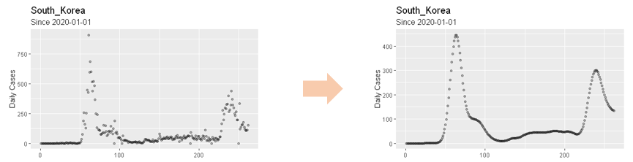

**Figure 1**: Daily new confirmed cases before and after Nadaraya-Watson kernel regression.

Peak detection (Algorithm 1) utilizes the first and second derivative test to find local maxima on convex function. has convexity when is around peak due to the nature of population dynamics. Considering daily new confirmed cases being discrete time series data, we find the location where the first difference is zero and second difference is negative (Since f(t) is not differentiable, we used difference operator instead of derivative):

, (3)

where and .

And for discontinuity and small variances of , we used following condition:

, (4)

where is sensitivity level and is set of time indices from January 1, 2020 to August 31, 2020 (Figure 2). And 3 additional conditions ((a) Exclusion of small peaks, (b) Resolution criteria and (c) Exclusion of peaks which are vibrations on increasing trend) are used in peak detection to enhance robustness. After all the peaks are found, breakpoints (Algorithm 2) are selected either as timestamps which have the smallest daily new confirmed cases between two consecutive peaks or the timestamp where the cumulative confirmed case of the last segment saturates (that is the last stage of the s-curve of last segment*).* Figure 2 visualizes the segmentation process. Blue line represents the peak and dotted sky-blue line represents breakpoint. In the 1st plot, black solid line represents and black dotted line represents . The 2nd plot represents cumulative confirmed cases of (black dotted line), (black solid line). 3rd, 4th plots are graphs of . In 4th plot, green dotted line represents sensitivity level. If is above the upper green dotted line, is considered to be concave. On the other hand, if is below the lower green dotted line, is considered to be convex. With 3rd, 4th plot, Equation (5) can be validated.

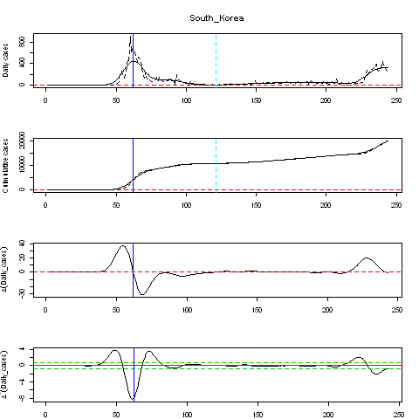

**Figure 2**: Segmentation algorithm on South Korea’s COVID-19 daily new confirmed cases.

The segmentation algorithm was successfully applied to 134 countries from the 213 countries in the ECDC dataset which met . If is too small, segmentation algorithm would be difficult to apply due to small variances in . The pseudo code of Segmentation and result of Segmentation on main countries are added in the Supplementary materials.

**Segmented growth curve models**

Segmented growth curve models (segmented Logistic model and segmented Gompertz model) fit the above mentioned growth curve models ((1) and (2)) for each segment independently. These new models do not preserve continuity at breakpoints but this does not matter since the objective of our analysis is to condense daily new confirmed cases into several parameters() of the growth curves, not to accurately predict daily new confirmed cases.

(5)

(6)

where, is the number of cumulative cases at breakpoint, is indicator function where is the set of indices of segment and .

In this analysis, we considered 1st and 2nd segments only since most countries have 1 or 2 segments (1 segment: 62, 2 segments: 65, 3 segments: 7) The number of countries with three segments are very few making comparison analysis insignificant to use in Simple Linear regression analysis. For countries with more than 2 segments, the analysis period was cut off at the 2nd breakpoint. Therefore, for countries with 2 segments, segmented growth curve model produces two sets of parameters one set from each segment. Also, correlation analysis for segmented Logistic and Gompertz models with the log-scaled of parameters are performed to determine the similarity between the parameters across the two models.

**Simple Linear regression (SLR) model**

The above growth curve models summarized the transmission of the pandemic as three parameters (, , ) for countries with 1 segment and into six parameters(, , , , , ) for countries with more than 1 segment. Each of the parameters from the two models are then regressed against the time-independent variables shown in Table 1 as follows;

(7)

where Y is a segmented growth curve parameter (a, b or c) for model segment and country , and are regression coefficients, and is the time-independent variable. F- statistic is performed to test the significance of for each major time-independent variable with the aim of finding out if the variables have any significant relationship with y, a measure of the spread dynamics of COVID-19 for a country.

After the segmentation algorithm was applied to 134 countries, these countries were fitted to segmented Logistic and Gompertz model respectively. To filter out poorly fitted countries, we exclude countries whose MSSE (Mean Squared Scaled Error) is higher than 0.4 as defined below:

MSSE = (8)

where is the daily new confirmed cases is the, is the predicted value for by segmented Logistic and Gompertz Model, and is the mean of for t = 1, …, N.

MSSE is more suitable scale than MSE(Mean Squared Error) or MAPE(Mean Absolute Percentage Error) because the former cannot control different scales according to the cumulative confirmed cases of each country, while the latter overestimates its error when the number of daily cases is small, especially approximating to zero. Of the 134 countries, only 124 using Logistic and 119 countries using Gompertz have fitted parameter values while the other countries returned NA values due to failure of converges in the fitting models. Among the fitted countries (124, 119), 5 countries are excluded due to failure of meeting the MSSE criteria of 0.4. Therefore, a total of 119 countries are used in the SLR model with only 114 countries using the Gompertz model, as shown in Figure 3 below;

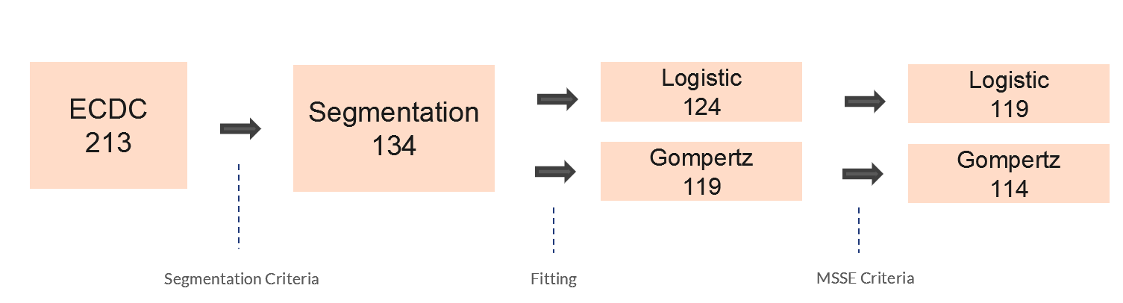

**Figure 3**: Variation of the number countries across segmentation, growth curve models and MSSE criteria

1. **Pseudo-code of Segmentation Algorithm**

Here, we denote by .

|  |
| --- |
| **Algorithm 1** Peak Detection Algorithm |
| 1. (Initialization)  declare where  2. (Local maximum condition)  **while** **do**  **if** **then**    **end if**  **end while**  3. (Excluding small peaks)  **if** **then**    **end if**  4. (Resolution criteria)  **if** **then**  declare *p* = 1,  **while** *p* **do**  **if** **then**  **if** **then**    **else**    **end if**  **else**    **end if**  *p* *p+1*  **end if**  5. (Exclude peaks which are vibrations on increasing trend)  **if** **then**  declare ;  **if** **then**    **end if**  **end if** |

|  |
| --- |
| **Algorithm 2** Breakpoint Detection Algorithm |
| 1. (Initialization)  declare  2. (Between peaks)  **if** **then**  **for each** **do**  B;  **end do**  **end if**  3.(After the last peak)  declare U  **if** **then**  B ;  **end if** |

|  |
| --- |
| **Algorithm 2** Breakpoint Detection Algorithm |
| 1. (Initialization)  declare  2. (Between peaks)  **if** **then**  **for each** **do**  B;  **end do**  **end if**  3.(After the last peak)  declare U  **if** **then**  B ;  **end if** |

**Figure S1:** Pseudo-codes for the Segmentation Algorithm

1. **Segmentation Results**

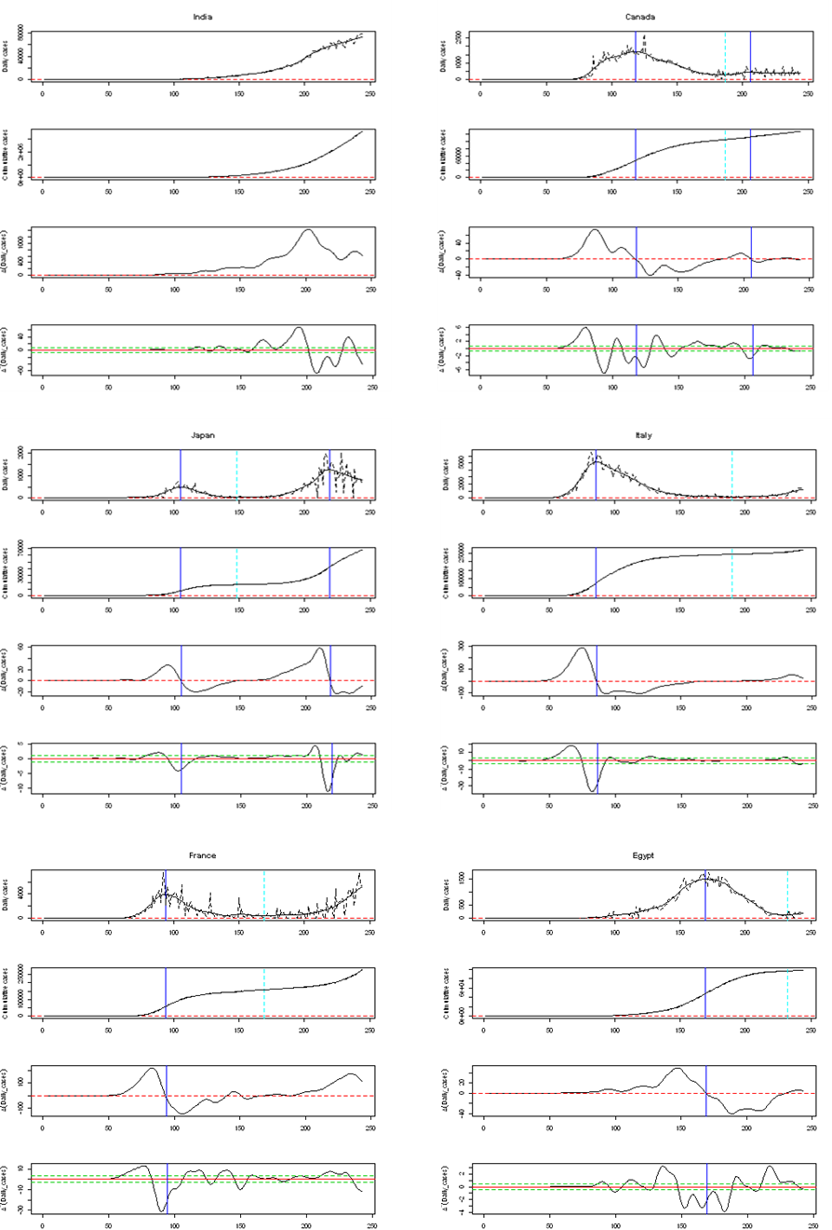

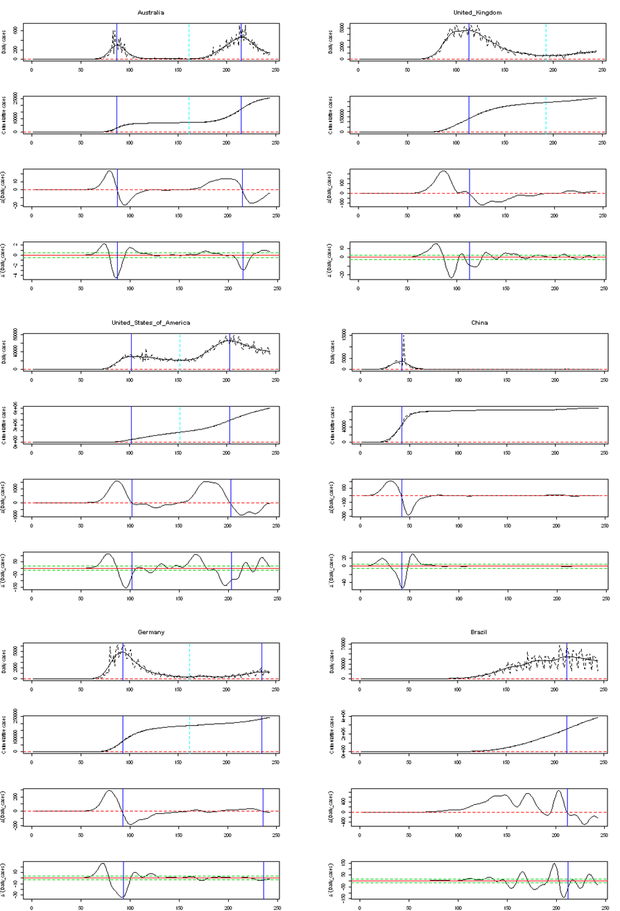

**Figure S2: The segmentation results for ten countries from the Segmentation Algorithm**. For each country, blue line represents the peak and dotted sky-blue line represents breakpoint. In the 1st plot, black solid line represents and black dotted line represents . The 2nd plot represents cumulative confirmed cases of (black dotted line), (black solid line). 3rd, 4th plots are graphs of . In 4th plot, green dotted line represents sensitivity level. If is above the upper green dotted line, is considered to be concave. On the other hand, if is below the lower green dotted line, is considered to be convex.

1. **Results from the segment growth curve models**

|  |  |  |  |  |  |  |  |  |
| --- | --- | --- | --- | --- | --- | --- | --- | --- |
| **Segmented Logistic Model** | | | | | | | | |
|  |  | **1st Segment** | | | **2nd Segment** | | |  |
| **Country** | **Maximum Cumulative cases** | **a** | **b** | **c** | **a** | **b** | **c** | **MSSE** |
| Afghanistan | 38162 | 37269.8509 | 5.6770 | 0.0743 | NA | NA | NA | 0.0285 |
| Albania | 9380 | 29521.2462 | 5.3078 | 0.0268 | NA | NA | NA | 0.0292 |
| Algeria | 44146 | 12006.8756 | 3.7504 | 0.0622 | 34805.8852 | 3.8383 | 0.0758 | 0.0296 |
| Angola | 2624 | 3210.7931 | 5.3484 | 0.0605 | NA | NA | NA | 0.1101 |
| Argentina | 401226 | 648605.7127 | 7.0822 | 0.0434 | NA | NA | NA | 0.0253 |
| Armenia | 43750 | 43766.2039 | 5.5276 | 0.0542 | NA | NA | NA | 0.0164 |
| Aruba | 1997 | 2036.3519 | 23.7171 | 0.1651 | NA | NA | NA | 0.4136 |
| Australia | 25670 | 6874.2219 | 5.5232 | 0.1993 | 19130.8848 | 5.7873 | 0.1019 | 0.0723 |
| Austria | 27218 | 15908.5183 | 4.2740 | 0.1596 | 16850.1551 | 3.8620 | 0.0498 | 0.1512 |
| Azerbaijan | 36309 | 39349.2968 | 5.7054 | 0.0523 | 2314.9887 | 3.1543 | 0.3069 | 0.0355 |
| Bahamas | 2167 | 2725.7862 | 11.5786 | 0.0902 | NA | NA | NA | 0.1529 |
| Bahrain | 51574 | 52482.2417 | 5.2532 | 0.0432 | NA | NA | NA | 0.0522 |
| Bangladesh | 310822 | 309918.2068 | 4.8411 | 0.0488 | NA | NA | NA | 0.0632 |
| Belarus | 71687 | 67674.9628 | 4.3724 | 0.0640 | 3143.6539 | 3.1136 | 0.2155 | 0.0513 |
| Belgium | 85442 | 59026.3230 | 4.1785 | 0.1002 | 25594.5256 | 4.4737 | 0.0989 | 0.0589 |
| Bolivia | 115968 | 136119.5696 | 5.7989 | 0.0465 | NA | NA | NA | 0.0150 |
| Bosnia and Herzegovina | 19789 | NA | NA | NA | NA | NA | NA | NA |
| Brazil | 3862311 | 4453662.2090 | 5.5266 | 0.0408 | NA | NA | NA | 0.0335 |
| Bulgaria | 16190 | 2847.4247 | 3.4207 | 0.0696 | 14226.6135 | 4.0922 | 0.0691 | 0.0347 |
| Cameroon | 19142 | 21027.7178 | 4.5991 | 0.0509 | 6228.8127 | 2.3642 | 0.1062 | 0.2697 |
| Canada | 127940 | 102198.2467 | 4.1626 | 0.0711 | 23205.5724 | 2.7602 | 0.0880 | 0.0676 |
| Cape Verde | 3852 | 451.6892 | 3.0462 | 0.1095 | 3709.0145 | 3.4858 | 0.0529 | 0.0886 |
| Central African Republic | 4700 | 4681.4703 | 4.6191 | 0.0867 | NA | NA | NA | 0.0584 |
| Chile | 409974 | 386213.7660 | 6.2397 | 0.0635 | NA | NA | NA | 0.1951 |
| China | 89868 | 84438.2778 | 5.2721 | 0.1958 | NA | NA | NA | 0.3252 |
| Colombia | 607938 | 1028559.6439 | 7.1185 | 0.0441 | NA | NA | NA | 0.0114 |
| Congo | 3979 | 4512.6300 | 5.1438 | 0.0508 | NA | NA | NA | 0.2155 |
| Costa Rica | 39699 | 53094.5266 | 8.5012 | 0.0555 | NA | NA | NA | 0.0682 |
| Cote dIvoire | 17948 | 19182.4988 | 5.3947 | 0.0525 | 889.9903 | 3.0251 | 0.3372 | 0.0898 |
| Croatia | 10123 | 2171.0152 | 3.1237 | 0.1317 | 13184.8289 | 4.3545 | 0.0482 | 0.2648 |
| Cuba | 3973 | 1856.7584 | 3.4571 | 0.1238 | 424.2954 | 3.0161 | 0.1868 | 0.0354 |
| Czechia | 24367 | 8425.2168 | 3.4373 | 0.1147 | 20390.7458 | 3.6332 | 0.0476 | 0.1193 |
| Democratic Republic of the Congo | 10044 | 9704.1760 | 4.8552 | 0.0575 | 208.7552 | 3.3273 | 0.6117 | 0.0521 |
| Denmark | 16700 | 12229.4185 | 3.0248 | 0.0747 | 4665.2456 | 4.2840 | 0.1044 | 0.1107 |
| Djibouti | 5385 | 1051.5098 | 4.9399 | 0.3115 | 3980.2177 | 4.0720 | 0.1357 | 0.2622 |
| Dominican Republic | 94241 | 143968.8886 | 4.5142 | 0.0321 | NA | NA | NA | 0.0887 |
| Ecuador | 117639 | 41796.9588 | 5.4738 | 0.1175 | 84434.3146 | 3.0774 | 0.0511 | 0.2161 |
| Egypt | 98727 | 99949.4036 | 6.4644 | 0.0618 | NA | NA | NA | 0.0104 |
| El Salvador | 25729 | 34877.7380 | 5.4834 | 0.0438 | NA | NA | NA | 0.0450 |
| Equatorial Guinea | 4941 | 1692.8579 | 3.5291 | 0.0881 | 1949.5310 | 5.0940 | 0.2163 | 0.6387 |
| Estonia | 2373 | 1856.0023 | 2.6937 | 0.1019 | 534.2583 | 4.6425 | 0.0788 | 0.2039 |
| Eswatini | 4561 | 6353.9951 | 5.1505 | 0.0475 | NA | NA | NA | 0.0585 |
| Ethiopia | 51122 | NA | NA | NA | NA | NA | NA | NA |
| Finland | 8077 | 7134.7878 | 3.2117 | 0.0755 | 1033.3456 | 4.0422 | 0.0980 | 0.0628 |
| France | 278709 | 147092.5435 | 4.6031 | 0.1069 | NA | NA | NA | 0.1265 |
| Gabon | 8505 | 3546.9607 | 5.1536 | 0.1172 | 2908.7589 | 3.0856 | 0.1821 | 0.0465 |
| Gambia | 2963 | 3105.6876 | 6.4323 | 0.1387 | NA | NA | NA | 0.0751 |
| Georgia | 1487 | 175285.9159 | 4.7540 | 0.1159 | 152925.9558 | 3.6806 | 0.0373 | 0.0995 |
| Germany | 242381 | 9712.5829 | 5.4931 | 0.1023 | 41388.5308 | 3.5723 | 0.0616 | 0.1187 |
| Greece | 10134 | 2731.1379 | 3.3367 | 0.1120 | NA | NA | NA | 0.0929 |
| Guam | 1347 | NA | NA | NA | NA | NA | NA | NA |
| Guatemala | 73912 | 80489.4110 | 6.0005 | 0.0525 | NA | NA | NA | 0.0586 |
| Guinea | 9371 | 5303.4292 | 3.3438 | 0.0680 | 4510.1775 | 2.8192 | 0.0736 | 0.0819 |
| Haiti | 8209 | 7622.6502 | 4.7753 | 0.0824 | NA | NA | NA | 0.1544 |
| Honduras | 60174 | 56907.2114 | 6.3830 | 0.0564 | 11520.8129 | 3.0437 | 0.2570 | 0.0551 |
| Hungary | 5961 | 3964.0412 | 3.4650 | 0.0889 | 4036.5004 | 4.4656 | 0.0535 | 0.2645 |
| Iceland | 2105 | 1782.3982 | 4.3145 | 0.1763 | 478.7850 | 7.1262 | 0.0717 | 0.1771 |
| India | 3621245 | 6765888.4642 | 7.1224 | 0.0410 | NA | NA | NA | 0.0045 |
| Indonesia | 172053 | 245161.5902 | 4.7788 | 0.0316 | NA | NA | NA | 0.0201 |
| Iran | 373570 | 94307.3179 | 4.5510 | 0.1102 | 279269.4435 | 2.9052 | 0.0432 | 0.0531 |
| Iraq | 231177 | 286347.3795 | 7.2230 | 0.0466 | NA | NA | NA | 0.0971 |
| Ireland | 28760 | 25830.5125 | 4.2620 | 0.1063 | NA | NA | NA | 0.1508 |
| Honduras | 60174 | 16392.4036 | 4.3321 | 0.1391 | 81068.1196 | 6.1544 | 0.0895 | 0.0666 |
| Italy | 268366 | 234107.3748 | 4.0454 | 0.0874 | 152109.5321 | 4.8147 | 0.0551 | 0.1475 |
| Jamaica | 2357 | NA | NA | NA | NA | NA | NA | NA |
| Japan | 67865 | 16549.7588 | 7.8244 | 0.1231 | 58877.8030 | 6.7353 | 0.0859 | 0.0472 |
| Kazakhstan | 130673 | NA | NA | NA | NA | NA | NA | NA |
| Kenya | 34057 | 44506.1507 | 6.7577 | 0.0519 | NA | NA | NA | 0.0686 |
| Kosovo | 13334 | 19149.3567 | 5.9962 | 0.0424 | NA | NA | NA | 0.1251 |
| Kuwait | 84636 | 67873.6972 | 5.5275 | 0.0521 | 16566.5209 | 2.7567 | 0.1815 | 0.1562 |
| Kyrgyzstan | 43898 | 43306.2180 | 14.1798 | 0.1217 | NA | NA | NA | 1.0229 |
| Lebanon | 16870 | NA | NA | NA | NA | NA | NA | NA |
| Luxembourg | 8010 | 50974.5449 | 8.4007 | 0.0547 | NA | NA | NA | 0.0772 |
| Madagascar | 14843 | 3849.0711 | 3.0137 | 0.1560 | 3829.1249 | 5.4731 | 0.1022 | 0.1072 |
| Malawi | 5536 | 15669.2011 | 9.1087 | 0.0789 | NA | NA | NA | 0.0803 |
| Malaysia | 9334 | 427.7014 | 7.2719 | 0.2915 | 5118.5363 | 3.6000 | 0.0826 | 0.0599 |
| Maldives | 7667 | 6372.3634 | 3.9217 | 0.1149 | 2242.5502 | 2.1243 | 0.0925 | 0.2918 |
| Luxembourg | 8010 | 2220.3578 | 3.0390 | 0.0913 | 6468.6466 | 4.3292 | 0.0850 | 0.1165 |
| Mauritania | 7022 | 6640.6373 | 3.9054 | 0.0898 | NA | NA | NA | 0.1372 |
| Mexico | 641442 | 718779.9196 | 5.0133 | 0.0393 | NA | NA | NA | 0.0171 |
| Moldova | 36700 | 30054.5755 | 3.7987 | 0.0377 | 21681.3023 | 2.9687 | 0.0787 | 0.0713 |
| Montenegro | 4790 | 5040.4658 | 9.0828 | 0.0713 | 555.1335 | 3.0227 | 0.4366 | 0.3103 |
| Morocco | 61399 | NA | NA | NA | NA | NA | NA | NA |
| Mozambique | 3821 | 8769.4296 | 4.7192 | 0.0336 | NA | NA | NA | 0.0722 |
| Namibia | 7365 | 19752.6493 | 4.6521 | 0.0557 | NA | NA | NA | 0.0369 |
| Nepal | 38561 | 18780.2065 | 6.6411 | 0.1098 | 30689.6636 | 4.1320 | 0.1019 | 0.0727 |
| Netherlands | 70071 | 47727.8050 | 3.8502 | 0.0920 | 21992.4891 | 4.7197 | 0.1103 | 0.0793 |
| New Zealand | 1387 | 1117.4873 | 3.3022 | 0.2346 | NA | NA | NA | 0.0959 |
| Nicaragua | 4494 | 4483.4442 | 2.0435 | 0.0494 | NA | NA | NA | 0.2250 |
| Niger | 1176 | 56771.2201 | 4.7597 | 0.0449 | NA | NA | NA | 0.0283 |
| Nigeria | 53865 | 1555.4972 | 3.4741 | 0.1320 | 12680.0369 | 3.8436 | 0.0549 | 0.0639 |
| Norway | 10543 | 8479.5156 | 3.2578 | 0.1023 | 1761.7727 | 4.5090 | 0.1300 | 0.1522 |
| Oman | 85544 | 89246.7641 | 6.5958 | 0.0616 | NA | NA | NA | 0.0878 |
| Pakistan | 295849 | 294439.8470 | 6.1567 | 0.0648 | NA | NA | NA | 0.0493 |
| Palestine | 29063 | 30248.6952 | 9.1084 | 0.0669 | NA | NA | NA | 0.1613 |
| Panama | 92065 | 117314.2780 | 4.9029 | 0.0364 | NA | NA | NA | 0.0192 |
| Paraguay | 17195 | NA | NA | NA | NA | NA | NA | NA |
| Peru | 647166 | 314970.4317 | 5.4482 | 0.0677 | 452678.9916 | 3.2689 | 0.0727 | 0.0345 |
| Philippines | 217396 | 7709617.3043 | 8.6352 | 0.0295 | NA | NA | NA | 0.1425 |
| Poland | 66870 | 37617.3841 | 3.2568 | 0.0471 | 37253.0201 | 3.3748 | 0.0810 | 0.0678 |
| Portugal | 57929 | 27725.1980 | 3.9706 | 0.1185 | 24053.6845 | 2.7848 | 0.0663 | 0.0624 |
| Puerto Rico | 32848 | 13037.7613 | 3.5594 | 0.0398 | 30810.2729 | 3.9246 | 0.0771 | 0.0734 |
| Qatar | 118575 | 114154.2700 | 5.3173 | 0.0617 | NA | NA | NA | 0.0291 |
| Romania | 86785 | 18736.0502 | 3.8730 | 0.0867 | 88299.9668 | 4.3176 | 0.0575 | 0.0456 |
| Russia | 990326 | 944933.9504 | 4.0525 | 0.0441 | NA | NA | NA | 0.1218 |
| Rwanda | 4020 | 8246.7708 | 4.9188 | 0.0283 | NA | NA | NA | 0.7079 |
| Saudi Arabia | 314821 | 320470.6504 | 5.0217 | 0.0474 | NA | NA | NA | 0.0383 |
| Senegal | 13556 | 14520.3585 | 3.8986 | 0.0356 | NA | NA | NA | 0.0869 |
| Serbia | 31365 | 10889.8012 | 4.6659 | 0.1250 | 20573.9984 | 4.3379 | 0.0792 | 0.0281 |
| Singapore | 56771 | 43064.6037 | 6.9493 | 0.0763 | 12182.6864 | 3.2260 | 0.1319 | 0.1479 |
| Slovakia | 3876 | 1502.3267 | 3.6374 | 0.1185 | 5628.8348 | 4.9385 | 0.0493 | 0.1520 |
| South Africa | 625056 | 657770.4040 | 8.8676 | 0.0697 | NA | NA | NA | 0.0165 |
| South Korea | 19947 | 10142.9519 | 3.1675 | 0.1737 | NA | NA | NA | 0.3329 |
| South Sudan | 2519 | 2034.9156 | 3.9351 | 0.1254 | 357.7103 | 3.2445 | 0.1936 | 0.1939 |
| Spain | 463943 | 232080.0683 | 4.5993 | 0.1206 | 519213.3489 | 5.8299 | 0.0646 | 0.1405 |
| Sudan | 13189 | 11334.2564 | 3.7113 | 0.0706 | 1447.2698 | 3.2426 | 0.2058 | 0.0992 |
| Suriname | 4009 | 6441.6655 | 4.3439 | 0.0529 | NA | NA | NA | 0.0399 |
| Sweden | 84233 | 88955.5267 | 3.6997 | 0.0388 | 9247.8436 | 2.9268 | 0.1461 | 0.0963 |
| Switzerland | 41906 | 30089.0565 | 4.3551 | 0.1421 | 16542.9808 | 4.3765 | 0.0534 | 0.0856 |
| Syria | 2703 | NA | NA | NA | NA | NA | NA | NA |
| Tajikistan | 8550 | 7809.6500 | 2.2830 | 0.0596 | NA | NA | NA | 0.2877 |
| Thailand | 3412 | 3129.1627 | 4.0437 | 0.1363 | NA | NA | NA | 0.4098 |
| Trinidad and Tobago | 1683 | NA | NA | NA | NA | NA | NA | NA |
| Tunisia | 3685 | 994.4882 | 2.9592 | 0.1432 | NA | NA | NA | 0.0916 |
| Turkey | 268546 | 198451.0508 | 2.9024 | 0.0638 | 50313.2130 | 2.8069 | 0.1128 | 0.2541 |
| Uganda | 3044 | 1077.7651 | 5.6711 | 0.0898 | NA | NA | NA | 0.2300 |
| Ukraine | 119074 | 202167.8426 | 3.9370 | 0.0252 | NA | NA | NA | 0.1084 |
| United Arab Emirates | 69690 | 60073.5725 | 4.2690 | 0.0514 | 8839.0863 | 3.0765 | 0.1818 | 0.0853 |
| United Kingdom | 334467 | 277495.8516 | 4.2224 | 0.0742 | 56759.8300 | 2.9675 | 0.0747 | 0.0735 |
| United States of America | 5997163 | 1683559.9636 | 5.2804 | 0.0846 | 4524204.7065 | 3.5090 | 0.0614 | 0.0656 |
| Uzbekistan | 41651 | 71893.9253 | 5.8737 | 0.0390 | NA | NA | NA | 0.0910 |
| Venezuela | 45868 | 101429.9411 | 7.4504 | 0.0446 | NA | NA | NA | 0.1045 |
| Zambia | 12025 | 25961.2086 | 6.1123 | 0.0441 | NA | NA | NA | 0.2871 |
| Zimbabwe | 6412 | 7030.4941 | 6.1792 | 0.0805 | NA | NA | NA | 0.1369 |

**Table S1: Parameter values estimated from segmented Logistic model**. is the maximum number of predicted cumulative confirmed cases, *b* is the time when we start to see a rise in the number of confirmed cases, *c* is the increase rate of the number of confirmed cases. NA indicates no values returned due to failure of the model to converge.

|  |  |  |  |  |  |  |  |  |
| --- | --- | --- | --- | --- | --- | --- | --- | --- |
|  | **Segmented Gompertz Model** | | | | | | | |
|  |  | **1st Segment** | | | **2nd Segment** | | |  |
| **Country** | **Maximum Cumulative cases** | **a** | **b** | **c** | **a** | **b** | **c** | **MSSE** |
| Afghanistan | 38162 | 38658.2222 | 25.0726 | 0.0471 | NA | NA | NA | 0.0609 |
| Albania | 9380 | NA | NA | NA | NA | NA | NA | NA |
| Algeria | 44146 | 18438.6969 | 5.2016 | 0.0253 | 44055.5472 | 5.8284 | 0.0364 | 0.0254 |
| Angola | 2624 | 8050.2783 | 8.3479 | 0.0185 | NA | NA | NA | 0.0974 |
| Argentina | 401226 | 4066522.7272 | 12.0418 | 0.0096 | NA | NA | NA | 0.0173 |
| Armenia | 43750 | 49098.8425 | 16.6368 | 0.0300 | NA | NA | NA | 0.0340 |
| Aruba | 1997 | NA | NA | NA | NA | NA | NA | NA |
| Australia | 25670 | 6951.4440 | 25.7079 | 0.1324 | 23230.6065 | 15.4190 | 0.0505 | 0.0557 |
| Austria | 27218 | 16155.0090 | 11.0045 | 0.1050 | 52770.0104 | 5.5194 | 0.0142 | 0.0947 |
| Azerbaijan | 36309 | 57315.1635 | 11.6912 | 0.0219 | 3083.2804 | 4.2461 | 0.1430 | 0.1164 |
| Bahamas | 2167 | 5701.9544 | 75.2460 | 0.0308 | NA | NA | NA | 0.1588 |
| Bahrain | 51574 | 66098.9116 | 11.4035 | 0.0207 | NA | NA | NA | 0.0264 |
| Bangladesh | 310822 | 382000.1473 | 9.6930 | 0.0240 | NA | NA | NA | 0.0181 |
| Belarus | 71687 | 71550.0996 | 10.0480 | 0.0389 | 5377.0525 | 4.1283 | 0.0834 | 0.0226 |
| Belgium | 85442 | 60644.2641 | 9.9910 | 0.0647 | 36686.9561 | 7.1235 | 0.0421 | 0.0271 |
| Bolivia | 115968 | 227156.0219 | 11.1086 | 0.0177 | NA | NA | NA | 0.0234 |
| Bosnia and Herzegovina | 19789 | NA | NA | NA | NA | NA | NA | NA |
| Brazil | 3862311 | 7198325.5242 | 10.3171 | 0.0160 | NA | NA | NA | 0.0094 |
| Bulgaria | 16190 | 4232.8425 | 4.5593 | 0.0290 | 17992.4458 | 6.4959 | 0.0330 | 0.0421 |
| Cameroon | 19142 | 108707.0966 | 6.8335 | 0.0119 | 6516.6774 | 3.3445 | 0.0703 | 0.2447 |
| Canada | 127940 | 109946.6392 | 8.5150 | 0.0420 | 27876.8064 | 3.6582 | 0.0460 | 0.0235 |
| Cape Verde | 3852 | 833.7525 | 4.0029 | 0.0399 | 5158.9832 | 4.8344 | 0.0235 | 0.0685 |
| Central African Republic | 4700 | 4833.5213 | 12.9590 | 0.0555 | NA | NA | NA | 0.0936 |
| Chile | 409974 | 415001.2049 | 29.4866 | 0.0376 | NA | NA | NA | 0.1943 |
| China | 89868 | 84708.4919 | 21.1560 | 0.1299 | NA | NA | NA | 0.5822 |
| Colombia | 607938 | 7084799.4030 | 11.9798 | 0.0094 | NA | NA | NA | 0.0533 |
| Congo | 3979 | 6520.0095 | 8.7962 | 0.0208 | NA | NA | NA | 0.3839 |
| Costa Rica | 39699 | 136895.5602 | 22.2936 | 0.0170 | NA | NA | NA | 0.0329 |
| Cote dIvoire | 17948 | 26535.0293 | 10.5070 | 0.0226 | 1163.2906 | 4.0580 | 0.1612 | 0.2006 |
| Croatia | 10123 | 2224.6337 | 5.2293 | 0.0869 | 35557.9695 | 6.2427 | 0.0144 | 0.2303 |
| Cuba | 3973 | 2044.3069 | 5.4702 | 0.0707 | 464.3771 | 4.3821 | 0.1089 | 0.0218 |
| Czechia | 24367 | 8766.2736 | 6.1152 | 0.0727 | 47008.7555 | 5.0086 | 0.0155 | 0.0728 |
| Democratic Republic of the Congo | 10044 | 10736.4218 | 11.8301 | 0.0324 | 274.5472 | 4.6493 | 0.2899 | 0.0508 |
| Denmark | 16700 | 12688.0788 | 4.8168 | 0.0481 | 8468.0207 | 6.0552 | 0.0374 | 0.0926 |
| Djibouti | 5385 | 1128.0306 | 13.5460 | 0.1842 | 4055.6841 | 8.8338 | 0.0856 | 0.2978 |
| Dominican Republic | 94241 | 494048.5687 | 6.4591 | 0.0086 | NA | NA | NA | 0.1698 |
| Ecuador | 117639 | 48988.1455 | 13.5407 | 0.0597 | 118443.9190 | 4.0637 | 0.0228 | 0.2421 |
| Egypt | 98727 | 112100.7245 | 27.5626 | 0.0341 | 3048.1640 | 3.8200 | 0.1437 | 0.0843 |
| El Salvador | 25729 | 84767.4806 | 8.6124 | 0.0134 | NA | NA | NA | 0.1306 |
| Equatorial Guinea | 4941 | 2947.6606 | 4.7078 | 0.0329 | 2242.6633 | 11.3615 | 0.1124 | 0.6882 |
| Estonia | 2373 | 1898.7892 | 4.0019 | 0.0674 | 2204.7769 | 6.8346 | 0.0199 | 0.1693 |
| Eswatini | 4561 | 19034.0804 | 7.6768 | 0.0133 | NA | NA | NA | 0.1214 |
| Ethiopia | 51122 | NA | NA | NA | NA | NA | NA | NA |
| Finland | 8077 | 7383.6402 | 5.3518 | 0.0485 | 2396.7520 | 5.6497 | 0.0314 | 0.0416 |
| France | 278709 | 151791.8661 | 12.8923 | 0.0683 | NA | NA | NA | 0.0523 |
| Gabon | 8505 | 6670.3765 | 8.3496 | 0.0416 | 3268.2183 | 4.3985 | 0.1016 | 0.0552 |
| Gambia | 2963 | 4460.8609 | 16.3888 | 0.0590 | NA | NA | NA | 0.0822 |
| Georgia | 1487 | 180590.9806 | 14.3623 | 0.0745 | 1399965.8160 | 6.0875 | 0.0076 | 0.0475 |
| Germany | 242381 | 43428.0235 | 8.2229 | 0.0245 | 50878.8766 | 5.1497 | 0.0303 | 0.1860 |
| Greece | 10134 | 2850.2120 | 5.6666 | 0.0705 | NA | NA | NA | 0.0592 |
| Guam | 1347 | NA | NA | NA | NA | NA | NA | NA |
| Guatemala | 73912 | 120849.4230 | 12.8995 | 0.0215 | NA | NA | NA | 0.0557 |
| Guinea | 9371 | 6276.1720 | 4.8603 | 0.0356 | 5896.6630 | 3.6876 | 0.0353 | 0.0422 |
| Haiti | 8209 | 7919.9844 | 14.2064 | 0.0522 | NA | NA | NA | 0.0596 |
| Honduras | 60174 | 94977.9591 | 13.7684 | 0.0214 | 16635.0074 | 4.0325 | 0.1127 | 0.0782 |
| Hungary | 5961 | 4158.2722 | 6.0539 | 0.0554 | 90891.8764 | 7.8593 | 0.0089 | 0.2417 |
| Iceland | 2105 | 1815.9673 | 11.4017 | 0.1168 | 6308.7422 | 11.2834 | 0.0124 | 0.2764 |
| India | 3621245 | 87187036.6787 | 11.8631 | 0.0075 | NA | NA | NA | 0.0204 |
| Indonesia | 172053 | 798318.0620 | 7.0186 | 0.0087 | NA | NA | NA | 0.0084 |
| Iran | 373570 | 118567.0986 | 7.9497 | 0.0523 | 348087.8281 | 3.8623 | 0.0216 | 0.0349 |
| Iraq | 231177 | 565000.6425 | 17.3186 | 0.0163 | NA | NA | NA | 0.0389 |
| Ireland | 28760 | 26103.4687 | 11.1085 | 0.0707 | NA | NA | NA | 0.1597 |
| Honduras | 60174 | 17138.7762 | 10.4599 | 0.0872 | 125660.9635 | 13.5198 | 0.0359 | 0.0430 |
| Italy | 268366 | 239477.4394 | 9.4656 | 0.0574 | NA | NA | NA | 0.0219 |
| Jamaica | 2357 | NA | NA | NA | NA | NA | NA | NA |
| Japan | 67865 | 17531.5024 | 89.4251 | 0.0760 | 98622.3568 | 15.6933 | 0.0325 | 0.0955 |
| Kazakhstan | 130673 | NA | NA | NA | NA | NA | NA | NA |
| Kenya | 34057 | 99124.7710 | 13.0280 | 0.0165 | NA | NA | NA | 0.1973 |
| Kosovo | 13334 | 79700.2167 | 9.2221 | 0.0103 | NA | NA | NA | 0.2460 |
| Kuwait | 84636 | 82441.1292 | 14.3643 | 0.0264 | 20197.2297 | 3.6386 | 0.0935 | 0.0725 |
| Kyrgyzstan | 43898 | 45547.7268 | 5355.3572 | 0.0766 | NA | NA | NA | 1.2727 |
| Lebanon | 16870 | NA | NA | NA | NA | NA | NA | NA |
| Luxembourg | 8010 | NA | NA | NA | NA | NA | NA | NA |
| Madagascar | 14843 | 3911.1573 | 5.0182 | 0.1050 | 4326.7213 | 15.6462 | 0.0556 | 0.0534 |
| Malawi | 5536 | 18617.7675 | 91.9470 | 0.0405 | NA | NA | NA | 0.2242 |
| Malaysia | 9334 | 560.8286 | 29.4977 | 0.1370 | 5847.5530 | 5.6631 | 0.0448 | 0.0626 |
| Maldives | 7667 | 6865.9962 | 7.4158 | 0.0678 | 2302.4141 | 2.8881 | 0.0620 | 0.2145 |
| Luxembourg | 8010 | 2481.8562 | 4.3299 | 0.0516 | 13064.4175 | 6.1831 | 0.0290 | 0.0949 |
| Mauritania | 7022 | 6952.5768 | 7.9523 | 0.0559 | NA | NA | NA | 0.1181 |
| Mexico | 641442 | 1078940.7137 | 8.7075 | 0.0161 | NA | NA | NA | 0.0054 |
| Moldova | 36700 | 89476.8616 | 5.3770 | 0.0109 | 33783.2559 | 3.8986 | 0.0326 | 0.0632 |
| Montenegro | 4790 | 7276.4251 | 58.9567 | 0.0315 | 764.5359 | 4.0296 | 0.1998 | 0.3762 |
| Morocco | 61399 | NA | NA | NA | NA | NA | NA | NA |
| Mozambique | 3821 | 87202.3592 | 7.5356 | 0.0066 | NA | NA | NA | 0.0683 |
| Namibia | 7365 | 333497.1922 | 7.8533 | 0.0098 | NA | NA | NA | 0.0363 |
| Nepal | 38561 | 23759.6419 | 21.5334 | 0.0521 | 114201.0768 | 5.9905 | 0.0269 | 0.1086 |
| Netherlands | 70071 | 49107.7894 | 7.9913 | 0.0590 | 38774.5904 | 7.2102 | 0.0405 | 0.0432 |
| New Zealand | 1387 | 1127.1035 | 6.1202 | 0.1598 | NA | NA | NA | 0.0097 |
| Nicaragua | 4494 | 4915.0570 | 2.6343 | 0.0300 | NA | NA | NA | 0.1603 |
| Niger | 1176 | 73615.8370 | 8.6526 | 0.0208 | NA | NA | NA | 0.0222 |
| Nigeria | 53865 | 1874.5592 | 4.9774 | 0.0664 | 15364.7097 | 6.1098 | 0.0278 | 0.0358 |
| Norway | 10543 | 8618.0392 | 5.7781 | 0.0680 | 2843.9925 | 6.8781 | 0.0507 | 0.0812 |
| Oman | 85544 | 100763.2996 | 28.3321 | 0.0334 | NA | NA | NA | 0.1751 |
| Pakistan | 295849 | 313983.3281 | 28.4530 | 0.0386 | NA | NA | NA | 0.1366 |
| Palestine | 29063 | 42050.0663 | 59.6946 | 0.0299 | NA | NA | NA | 0.0633 |
| Panama | 92065 | 260971.5242 | 7.2872 | 0.0116 | NA | NA | NA | 0.0598 |
| Paraguay | 17195 | NA | NA | NA | NA | NA | NA | NA |
| Peru | 647166 | 446214.4655 | 10.7987 | 0.0290 | 846683.9627 | 4.3642 | 0.0264 | 0.0321 |
| Philippines | 217396 | NA | NA | NA | NA | NA | NA | NA |
| Poland | 66870 | 47514.4286 | 4.5190 | 0.0231 | 64104.7074 | 4.5054 | 0.0308 | 0.0361 |
| Portugal | 57929 | 29936.8951 | 7.6538 | 0.0699 | 29015.3918 | 3.6595 | 0.0343 | 0.0215 |
| Puerto Rico | 32848 | 65040.0602 | 5.4168 | 0.0096 | 50324.6920 | 5.5172 | 0.0301 | 0.0745 |
| Qatar | 118575 | 120095.6164 | 18.2530 | 0.0378 | NA | NA | NA | 0.0333 |
| Romania | 86785 | 21563.1947 | 6.5107 | 0.0466 | 216103.4983 | 6.0951 | 0.0177 | 0.0318 |
| Russia | 990326 | 1057244.6747 | 7.5490 | 0.0247 | NA | NA | NA | 0.0380 |
| Rwanda | 4020 | 160397.3892 | 8.3458 | 0.0048 | NA | NA | NA | 0.6512 |
| Saudi Arabia | 314821 | 375527.3377 | 11.0682 | 0.0244 | NA | NA | NA | 0.0589 |
| Senegal | 13556 | 19817.4519 | 5.8206 | 0.0161 | NA | NA | NA | 0.0395 |
| Serbia | 31365 | 11544.5233 | 11.9676 | 0.0755 | 24299.8019 | 7.8757 | 0.0408 | 0.0301 |
| Singapore | 56771 | 46555.2356 | 44.9176 | 0.0451 | 13163.0862 | 4.8592 | 0.0772 | 0.0811 |
| Slovakia | 3876 | 1564.7214 | 6.4994 | 0.0733 | 74539.1570 | 8.0670 | 0.0091 | 0.1994 |
| South Africa | 625056 | 787210.6110 | 75.3165 | 0.0351 | NA | NA | NA | 0.1231 |
| South Korea | 19947 | 10364.8855 | 5.4689 | 0.1147 | NA | NA | NA | 0.1889 |
| South Sudan | 2519 | 2147.1872 | 7.8644 | 0.0767 | 373.3645 | 5.1459 | 0.1199 | 0.2220 |
| Spain | 463943 | 237938.9846 | 13.3300 | 0.0784 | NA | NA | NA | 0.0279 |
| Sudan | 13189 | 12339.0733 | 6.4342 | 0.0410 | 1902.2561 | 4.4326 | 0.0969 | 0.0612 |
| Suriname | 4009 | 29831.0627 | 6.3839 | 0.0128 | NA | NA | NA | 0.0792 |
| Sweden | 84233 | 124252.7248 | 5.2176 | 0.0170 | 11067.5839 | 3.9308 | 0.0759 | 0.1109 |
| Switzerland | 41906 | 30687.3318 | 11.6364 | 0.0936 | 56221.8662 | 6.3637 | 0.0146 | 0.0491 |
| Syria | 2703 | NA | NA | NA | NA | NA | NA | NA |
| Tajikistan | 8550 | 8127.3560 | 3.2065 | 0.0399 | NA | NA | NA | 0.1665 |
| Thailand | 3412 | 3154.1186 | 9.3739 | 0.0897 | NA | NA | NA | 0.2209 |
| Trinidad and Tobago | 1683 | NA | NA | NA | NA | NA | NA | NA |
| Tunisia | 3685 | 1038.2063 | 4.5857 | 0.0915 | NA | NA | NA | 0.0306 |
| Turkey | 268546 | 207933.5885 | 4.5240 | 0.0409 | 68974.9480 | 3.6475 | 0.0517 | 0.1452 |
| Uganda | 3044 | 1188.0377 | 19.7095 | 0.0514 | NA | NA | NA | 0.1800 |
| Ukraine | 119074 | NA | NA | NA | NA | NA | NA | NA |
| United Arab Emirates | 69690 | 67678.3664 | 8.2582 | 0.0283 | 13578.4568 | 4.0506 | 0.0756 | 0.0398 |
| United Kingdom | 334467 | 291405.6852 | 9.4917 | 0.0458 | 99004.9490 | 3.9148 | 0.0286 | 0.0251 |
| United States of America | 5997163 | 1987478.8437 | 13.0915 | 0.0439 | 5952114.1576 | 4.8924 | 0.0284 | 0.0231 |
| Uzbekistan | 41651 | 788275.6765 | 9.1565 | 0.0072 | NA | NA | NA | 0.2148 |
| Venezuela | 45868 | 3551978.5884 | 12.7690 | 0.0067 | NA | NA | NA | 0.1627 |
| Zambia | 12025 | 31660320.7299 | 13.1480 | 0.0038 | NA | NA | NA | 0.4628 |
| Zimbabwe | 6412 | 10189.0969 | 14.4420 | 0.0338 | NA | NA | NA | 0.1983 |

**Table S2: Parameter values estimated from the segmented Gompertz model**. is the maximum number of predicted cumulative confirmed cases, *b* is the time when we start to see a rise in the number of confirmed cases, *c* is the increase rate of number of confirmed cases. NA indicates no values returned due to failure of the model to converge.

1. **Correlation analysis between Growth curve models and segments.**

Correlation analysis for segmented Logistic and Gompertz models with the log-scaled of parameters are performed to determine the similarity between the parameters across the two models.

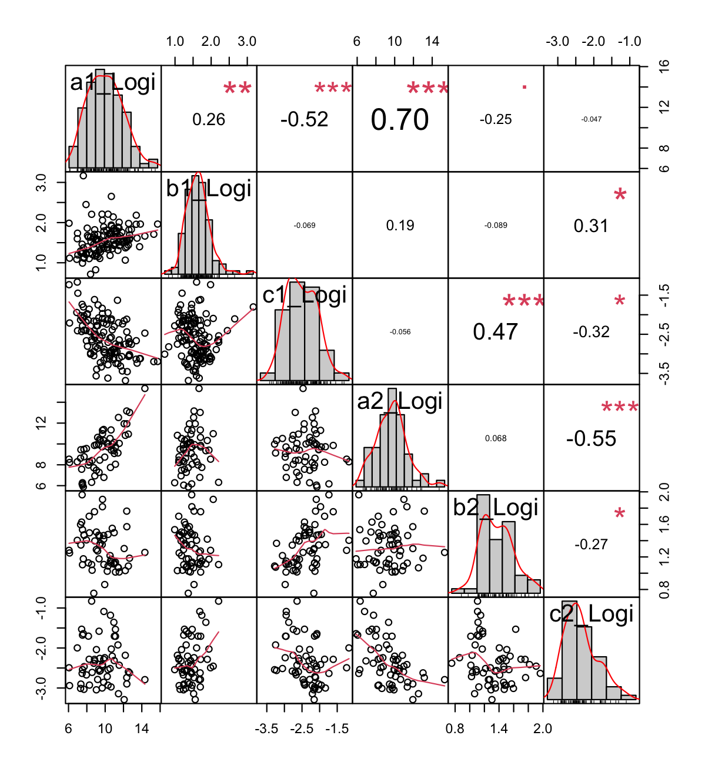

**Figure S3.** Comparison of Logistic Model (log-scaled) parameters a, b, and c in the 1st and 2nd segments.

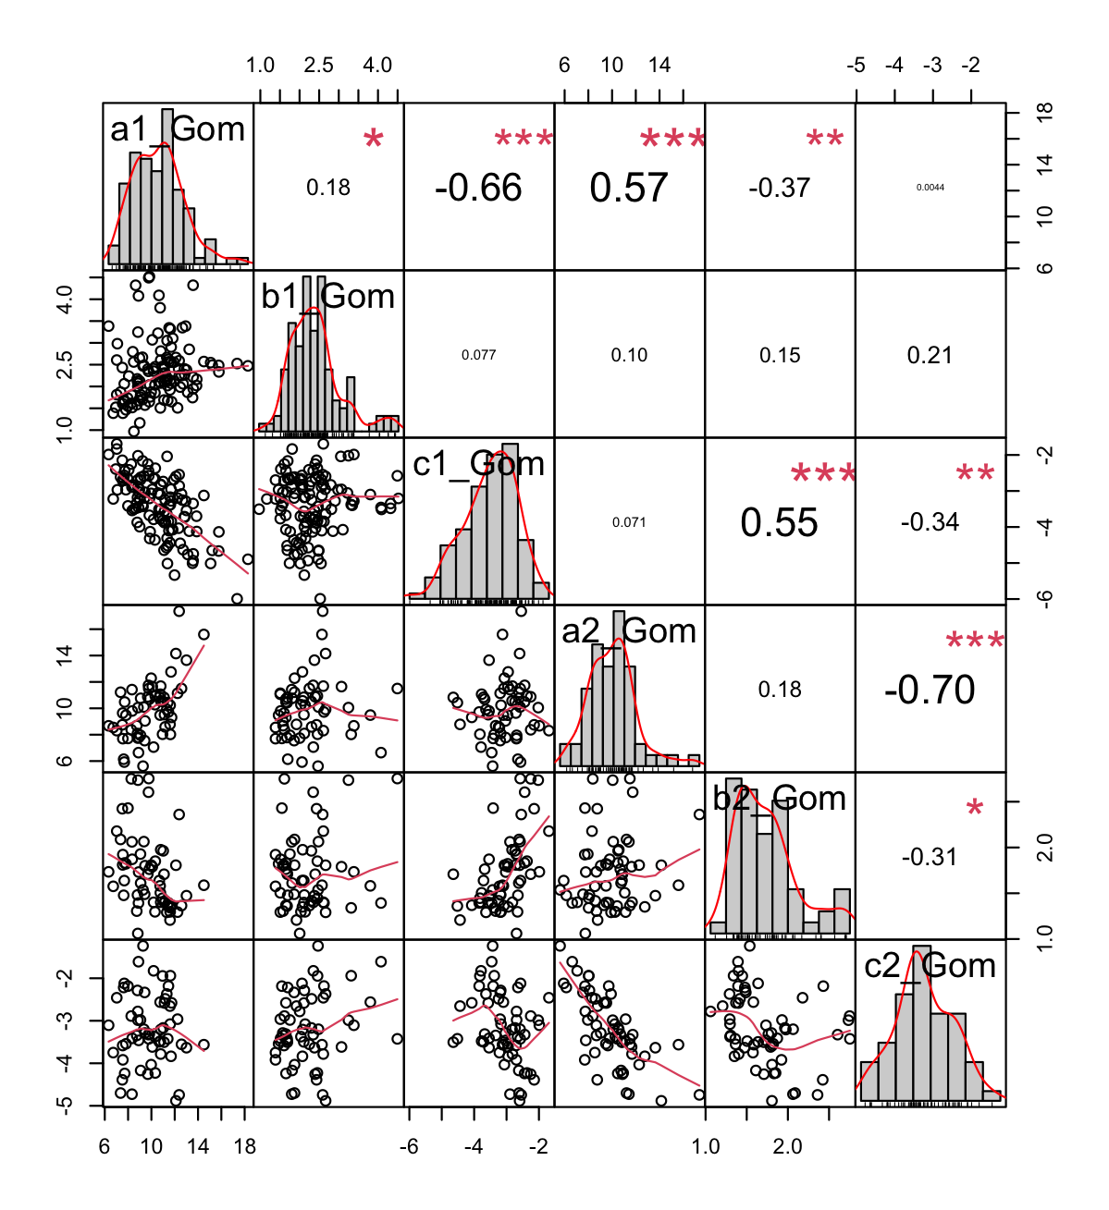

**Figure S4**. Comparison of Gompertz Model (log-scaled) parameters a, b, and c in the 1st and 2nd segments.

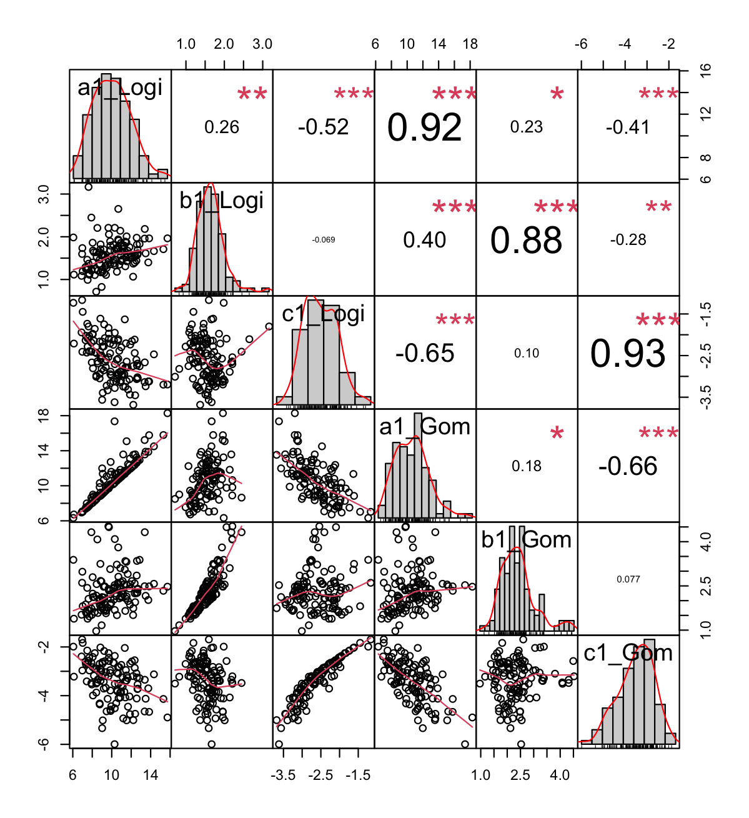

**Figure S5**. Comparison of Logistic and Gompertz Model (log-scaled) parameters a, b, and c in the 1st segment.

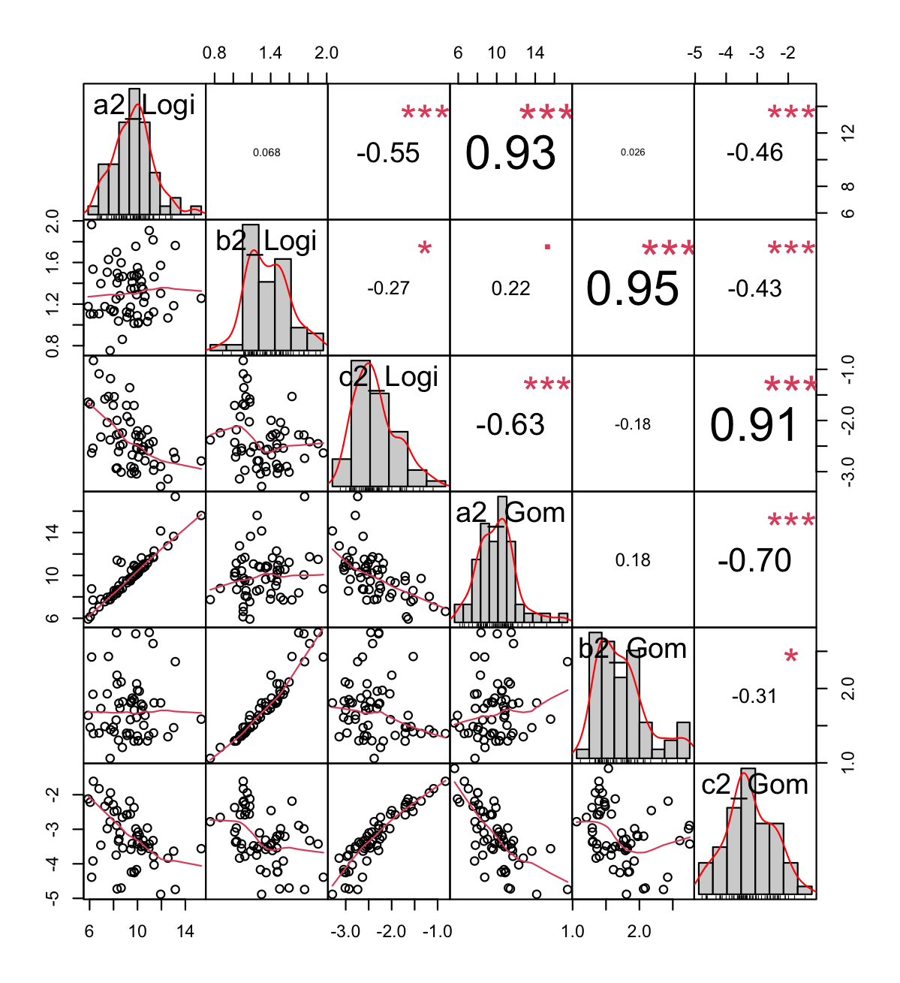

**Figure S6.** Comparison of Logistic and Gompertz Model (log-scaled) parameters a, b, and c in the 2nd segment.

|  |  |  |  |  |  |  |
| --- | --- | --- | --- | --- | --- | --- |
| **Results of SLR with the coefficients of Growth Curve Models** | | | | | | |
| **Sample size** | **Indicator\Parameter** | | **1st Segment** | | **2nd Segment** | |
| **Logistic** | **Gompertz** | **Logistic** | **Gompertz** |
| 113 | Child Vaccination rate |  | -14357.7282  (0.1007) | -7697.8508  (0.9204) | 2007.029  (0.8298) | 2259.3519  (0.8583) |
|  | -0.0223  (0.099) | -0.1518  (0.2962) | 0.027  (0.0962) | 0.0725  (0.1163) |
|  | 0.0008  (0.0474) | 0.0006  (0.0646) | -0.0021  (0.1748) | -0.0011  (0.1667) |
| 81 | Malnutrition rate |  | 21505.6496  (0.2794) | 159924.877  (0.3232) | -13713.3884  (0.6724) | -20286.5718  (0.6461) |
|  | 0.0946  (0.0001) | 0.6838  (0.0103) | -0.0974  (0.0723) | -0.2339  (0.1359) |
|  | -0.0019  (0.0046) | -0.0016  (0.1287) | 0.0057  (0.1189) | 0.0035  (0.0793) |
| 114 | Migration rate |  | -4020.2518  (0.8057) | -32813.5776  (0.8031) | 2330.3561  (0.8577) | 5990.4662  (0.7335) |
|  | 0.0026  (0.9168) | 0.1544  (0.5355) | 0.0157  (0.4904) | 0.0892  (0.1661) |
|  | 0.0009  (0.2363) | 0.0009  (0.0806) | -0.0006  (0.7824) | -0.0004  (0.7476) |
| 110 | Proportion of urban population |  | -3782.6928  (0.4555) | -54005.4974  (0.1873) | 3024.4618  (0.4972) | 4006.8512  (0.499) |
|  | -0.0074  (0.331) | 0.0025  (0.9734) | 0.014  (0.0661) | 0.0475  (0.0251) |
|  | 0.0002  (0.3689) | 0.0002  (0.1402) | -7.38E-05  (0.875) | -0.0001  (0.6895) |
| 21 | Public Social Welfare  (2018) |  | 6710.3933  (0.062) | 7221.391  (0.0529) | 5753.5048  (0.4085) | 12802.434  (0.5323) |
|  | 0.0052  (0.8547) | 0.0016  (0.9919) | -0.0767  (0.1826) | -0.1655  (0.3451) |
|  | -0.003  (0.1745) | -0.002  (0.1876) | 0.0018  (0.2895) | 0.002  (0.0866) |
| 46 | National Competitiveness  (2020) |  | 23675.7855  (0.0667) | 103012.669  (0.3459) | 2052.9728  (0.1115) | 2011.4374  (0.5367) |
|  | 0.0184  (0.1389) | 0.0324  (0.8188) | 0.004  (0.7601) | -0.008  (0.8468) |
|  | -0.0009  (0.0184) | -0.0007  (0.0148) | -0.001  (0.0015) | -0.0006  (0.0073) |
| 89 | Temperature |  | 1402.4882  (0.1151) | 4964.543  (0.509) | -150.59  (0.1513) | -260.3482  (0.2723) |
|  | 0.0027  (0.0165) | 0.011  (0.3739) | -0.002  (0.0689) | -0.0038  (0.2332) |
|  | -0.00005  (0.2258) | -0.00005  (0.051) | 0.0001  (0.0471) | 6.52E-05  (0.0712) |
| 89 | Rain |  | 416.336  (0.0284) | -30.8077  (0.9856) | -44.5106  (0.081) | -69.0218  (0.2293) |
|  | 0.0005  (0.0321) | 0.0032  (0.2413) | -0.0003  (0.2422) | -0.0004  (0.6443) |
|  | -4.53E-06  (0.6056) | -4.63E-06  (0.465) | 2.22E-05  (0.1653) | 1.06E-05  (0.2324) |
| 24 | Pharmacy Sales  (2018) |  | 1.7102  (0.2034) | 1.7161  (0.2288) | 2.7398  (0.0733) | 11.0062  (0.0066) |
|  | 4.67E-05  (0.0004) | 0.0008  (0.0001) | 1.43E-05  (0.3962) | 5.98E-05  (0.2885) |
|  | -2.03E-07  (0.7381) | -1.78E-07  (0.6785) | -3.73E-07  (0.3619) | -9.87E-08  (0.7302) |
| 89 | Exportation  (2016) |  | -9041.6085  (0.1413) | -49413.3181  (0.322) | -5212.9331  (0.212) | -6027.7869  (0.2838) |
|  |  | -0.0165  (0.0467) | -0.0453  (0.5576) | -0.0011  (0.8736) | -0.0044  (0.8287) |
|  | 0.0003  (0.1579) | 0.0003  (0.0377) | -0.0002  (0.6923) | -0.0002  (0.3716) |
| 89 | Importation  (2016) |  | -2445.1892  (0.4609) | -33355.1236  (0.219) | -5067.6788  (0.0496) | -6532.0368  (0.0621) |
|  | -0.0107  (0.0158) | -0.0783  (0.0602) | -0.0028  (0.529) | -0.01  (0.432) |
|  | -3.45E-05  (0.7728) | 4.32E-05  (0.626) | -9.66E-05  (0.7123) | -0.0002  (0.253) |
| 113 | Total GDP  (2018) |  | -469.0818  (0.8283) | -2018.1576  (0.9139) | -1601.5412  (0.3859) | -1741.6617  (0.4931) |
|  | 0.0006  (0.8578) | -0.0115  (0.7455) | 0.0022  (0.5079) | 0.0082  (0.3822) |
|  | -4.05E-05  (0.708) | 1.64E-05  (0.8238) | 0.0005  (0.1171) | 0.0002  (0.2968) |
| 113 | Per GDP  (2017) |  | -69.4978  (0.9721) | -11188.7115  (0.4906) | 1271.2564  (0.4289) | 1890.1551  (0.3847) |
|  | 0.0012  (0.6922) | 0.0281  (0.3597) | 0.0011  (0.6999) | -0.0012  (0.8844) |
|  | 0.0001  (0.1942) | 5.97E-05  (0.351) | 0.0002  (0.4333) | 4.38E-05  (0.7524) |
| 46 | Travel In  (2017) |  | 14436.9249  (0.4312) | -93051.2112  (0.5466) | 18392.0883  (0.1434) | 22169.6125  (0.1988) |
|  | 0.0148  (0.3844) | -0.0282  (0.8885) | 0.0104  (0.5094) | 0.0326  (0.4799) |
|  | 0.0004  (0.3608) | 0.0002  (0.497) | 0.0003  (0.5463) | 0.0009  (0.0378) |
| 46 | Travel Out  (2017) |  | 17955.4541  (0.0109) | 106595.937  (0.6203) | 22145.797  (0.1889) | 37366.3895  (0.0987) |
|  | -0.0099  (0.0038) | -0.0722  (0.7962) | -0.0255  (0.2201) | -0.0587  (0.3354) |
|  | -0.0014  (0.0422) | -0.001  (0.04) | -4.40E-05  (0.9499) | -0.0003  (0.5968) |
| 114 | Aging Index  (2020) |  | -1660.0337  (0.3755) | -10058.4878  (0.5089) | 378.74  (0.7873) | 956.7261  (0.6239) |
|  | -0.0096  (0.0007) | 0.0017  (0.9533) | 0.0079  (0.0007) | 0.0176  (0.0121) |
|  | 0.0002  (0.0094) | 0.0002  (0.00007) | -0.0006  (0.0058) | -0.0004  (0.0014) |
| 112 | GDP per Capita  (2019) |  | -3.8816  (0.3797) | -28.9139  (0.4185) | 4.5781  (0.1479) | 6.4778  (0.1279) |
|  | -1.49E-05  (0.0278) | 4.27E-06  (0.9497) | 1.81E-05  (0.0006) | 5.48E-05  (0.0002) |
|  | 6.36E-07  (0.0018) | 5.86E-07  (1.38E-05) | -9.13E-07  (0.0851) | -5.27E-07  (0.0482) |
| 114 | Birth Rate  (2020) |  | -60203.2289  (0.471) | -254796.137  (0.7092) | -36065.19  (0.6268) | -58281.0044  (0.562) |
|  | 0.219  (0.0886) | 0.2726  (0.8332) | -0.2791  (0.0291) | -0.5689  (0.1215) |
|  | -0.005  (0.2088) | -0.006  (0.0235) | 0.0446  (0.0002) | 0.0251  (2.38E-05) |
| 112 | Population Density |  | 10.5307  (0.9336) | 206.9605  (0.8381) | -22.5384  (0.7692) | -30.6368  (0.7685) |
|  | 0.0002  (0.2862) | 0.0037  (0.0636) | -3.64E-05  (0.7877) | -4.40E-05  (0.9088) |
|  | -1.64E-06  (0.7878) | -3.95E-07  (0.9235) | -8.03E-07  (0.9509) | 1.10E-06  (0.869) |
| 114 | Population |  | 0.0026  (5.13E-08) | 0.0549  (4.07E-48) | 0.0104  (9.58E-18) | 0.0136  (1.33E-16) |
|  | 1.03E-09  (0.2136) | 1.53E-09  (0.8906) | -5.01E-10  (0.8613) | -2.16E-09  (0.7871) |
|  | 9.60E-12  (0.6978) | -3.98E-11  (0.082) | -3.85E-11  (0.8894) | 4.24E-11  (0.7626) |
| 118 | Median Age |  | -4483.8362  (0.6693) | -32192.0147  (0.7069) | 3697.8388  (0.6451) | 7717.4043  (0.5157) |
|  | -0.0562  (0.0007) | -0.117  (0.4869) | 0.0437  (0.0029) | 0.0893  (0.0381) |
|  | 0.0011  (0.0233) | 0.0012  (0.0002) | -0.0043  (0.0022) | -0.0026  (0.0003) |
| 117 | Aged 65 older |  | -11175.5466  (0.4445) | -71743.0808  (0.5464) | 5802.4083  (0.6034) | 11255.2968  (0.4656) |
|  | -0.0828  (0.0003) | -0.1095  (0.6398) | 0.0692  (0.0002) | 0.1521  (0.0058) |
|  | 0.0019  (0.0058) | 0.0019  (3.24E-05) | -0.0052  (0.0045) | -0.0032  (0.0007) |
| 116 | Aged 70 older |  | -18316.6841  (0.395) | -116673.731  (0.5058) | 7885.3553  (0.6302) | 17152.5776  (0.4525) |
|  | -0.1238  (0.0003) | -0.1777  (0.6064) | 0.1008  (0.0002) | 0.2224  (0.0063) |
|  | 0.0027  (0.0076) | 0.0028  (4.04E-05) | -0.0076  (0.0051) | -0.0047  (0.0008) |
| 117 | GDP per Capita |  | -3.6787  (0.4153) | -29.3302  (0.4211) | 4.153  (0.2553) | 6.0046  (0.2222) |
|  | -1.48E-05  (0.0411) | -7.83E-06  (0.913) | 1.50E-05  (0.0171) | 4.66E-05  (0.0084) |
|  | 3.75E-07  (0.0823) | 4.18E-07  (0.004) | -1.00E-06  (0.1047) | -5.76E-07  (0.066) |
| 83 | Extreme poverty |  | -1019.7404  (0.8536) | 30482.0167  (0.6259) | -3737.9712  (0.5732) | -4780.8517  (0.5896) |
|  | 0.0259  (0.0059) | 0.2698  (0.0038) | -0.0139  (0.1732) | -0.0276  (0.3393) |
|  | 6.54E-05  (0.8401) | -0.0001  (0.6292) | 0.0034  (0.0004) | 0.0017  (0.0007) |
| 117 | Cardiovascular Death |  | 298.2246  (0.7108) | 1279.4536  (0.8419) | -646.4341  (0.3483) | -903.4116  (0.3143) |
|  | 0.0014  (0.2642) | 0.0053  (0.6763) | -0.0031  (0.0091) | -0.0078  (0.0164) |
|  | -9.37E-05  (0.0111) | --6.94E-05  (0.0066) | 0.0003  (00039) | 0.0002  (0.0022) |
| 117 | Diabetes prevalence |  | 18298.4575  (0.4938) | 169470.1553  (0.4333) | 22305.6187  (0.3388) | 24539.7118  (0.4086) |
|  | 0.0469  (0.277) | 0.2974  (0.4846) | -0.0971  (0.016) | -0.2339  (0.0298) |
|  | -0.0023  (0.0704) | -0.0014  (0.1028) | 0.0027  (0.49) | 0.0228  (0.143) |
| 95 | Female Smokers |  | -7740.7669  (0.4724) | -80694.6925  (0.3531) | 2370.4095  (0.7737) | 5223.5934  (0.6384) |
|  | -0.0419  (0.0044) | -0.0523  (0.7142) | 0.0274  (0.0442) | 0.0491  (0.2174) |
|  | 0.0008  (0.0932) | 0.0009  (0.0057) | -0.0002  (0.7954) | -0.0005  (0.2825) |
| 93 | Male Smokers |  | -4777.0122  (0.6028) | -77332.9445  (0.3089) | -6543.0171  (0.4668) | -8035.818  (0.4962) |
|  | -0.0197  (0.1202) | -0.0425  (0.7338) | -0.0155  (0.3013) | -0.0516  (0.2217) |
|  | -0.0003  (0.468) | -2.82E-05  (0.9236) | 0.0023  (0.0139) | 0.0013  (0.0109) |
| 52 | Handwashing Facilities |  | 6415.2357  (0.325) | 14642.0739  (0.7988) | 205.9126  (0.2045) | 223.3323  (0.4027) |
|  | 0.0021  (0.7639) | -0.0105  (0.887) | 0.006  (0.1339) | 0.0093  (0.2666) |
|  | -0.0002  (0.2888) | -3.26E-05  (0.7875) | -0.0013  (0.2382) | -0.0005  (0.2845) |
| 105 | Hospital Beds per Thousand |  | -59105.4423  (0.157) | -387458.616  (0.2634) | -16955.6263  (0.6042) | -5383.3531  (0.9029) |
|  | -0.1785  (0.0052) | 0.0532  (0.9351) | 0.1314  (0.0182) | 0.3867  (0.0141) |
|  | 0.0037  (0.0592) | 0.0037  (0.0061) | -0.0019  (0.6166) | -0.0026  (0.2003) |
| 117 | Life Expectancy |  | -3566.5625  (0.7852) | -54659.4445  (0.6054) | 6710.8788  (0.5402) | 10543.1521  (0.4844) |
|  | -0.0467  (0.0257) | -0.0769  (0.7119) | 0.0658  (0.0003) | 0.1511  (0.005) |
|  | 0.0013  (0.0401) | 0.0014  (0.0012) | -0.006  (0.0008) | -0.0035  (0.0001) |
| 116 | Human Development Index |  | -73966.9319  (0.9091) | -2915733.55  (0.5758) | 551874.391  (0.2845) | 849673.275  (0.2257) |
|  | -2.1542  (0.0372) | -4.1945  0.682) | 2.6642  (0.0024) | 5.9277  (0.0197) |
|  | 0.0397  (0.1997) | 0.0518  (0.0124) | -0.2589  (0.0022) | -0.1537  (0.0004) |

**Table S3**: **Results of the Simple Linear Regression**. The values are the coefficients () for the time-independent variables. The *p*-values are written in the brackets.